**Genetic markers combined with air pollution exposure in the development of lung cancer in a Northern Israeli cohort of different ethnic origins**

(Seminar work)

Nikolai Danilov, MD

University of Haifa

School of Public Health

Master of Public Health (Biostatistics) program

Environmental Epidemiology course

Dr. Jonathan Dubnov, MD, MPH

Haifa, 2025

# Table of Contents

Table of Contents 2

Part I. INTRODUCTION 6

Part II. LITERATURE REVIEW 7

Chapter 2.1. Lung Cancer Burden in Israel 7

Chapter 2.2. Role of Genetic Markers in Lung Cancer 10

PD-L1 10

MET 10

EGFR 11

BRAF 11

KRAS 11

ERBB2 (HER2) 12

ALK 12

ROS1 13

NTRK 13

RET 13

Mismatch Repair Genes 14

Chapter 2.3. Role of Air Pollution in Lung Cancer 15

NO₂ 15

Other NOx 16

CO 16

SO₂ 16

O₃ 17

PM₁₀ 17

PM₂.₅ 17

Part III. DATA ANALYSIS 19

Chapter 3.1. Environmental Exposure (Air Pollution) Data 20

Background 20

Objectives 21

Data Sources 22

Analyses and Their Results 23

PM₂.₅ 23

PM₁₀ 25

O3 27

SO2 29

NOx 31

NO2 33

CO 35

Summary 37

Chapter 3.2. Clinical-Laboratory Data (Lung Cancer Diagnosis) 38

Background 38

Objectives 39

Data Source 40

Data Dictionary (Clinical-Laboratory Variables) 41

Data Preprocessing 44

Methods 45

Analyses and Their Results 46

Demographics of the Study Cohort 46

Histopathological subtypes, biomarker distribution, and tumour mutational burden 49

Geographic distribution of lung cancer cases 51

Statistical Testing of Spatial Clustering 60

Local indicators of spatial association 63

Limitations and potential confounders 67

Smoking As a Potential Confounder 68

Synthesis and Interpretation 70

Ethnicity as a potential determinant 71

Summary 73

Chapter 3.3. Cross-Synthesis of Environmental and Clinical-Laboratory Data 74

Approach Applied 74

Findings and Observations 74

Interpretation and implications 75

Summary 75

Part IV. DISCUSSION 77

Interpretation of Key Findings 77

Comparison with existing literature 77

Public Health and Clinical Implications 78

Limitations 78

Part V. CONCLUSIONS AND RECOMMENDATIONS 80

Summary of observed patterns 80

Recommendations 80

REFERENCES 82

APPENDICES 86

Appendix A. Raw Data Sets 86

Appendix B. Selected R Code Scripts (For the Data Preprocessing) 87

Appendix C. Declaration of authenticity 89

# Part I. INTRODUCTION

***Lung cancer (LC)*** remains the leading cause of cancer mortality worldwide and poses a major public health burden. Despite advances in screening and treatment, survival rates remain poor, largely due to late-stage diagnosis and complex etiological factors. The development of LC is driven by a combination of genetic susceptibility and environmental exposures, particularly ***air pollution***, which is recognized as a Group 1 carcinogen by the International Agency for Research on Cancer (IARC).

The relevance of this topic is multidimensional. Clinically, ***LC*** represents a critical challenge in oncology due to its heterogeneous nature and frequent resistance to targeted therapies. Epidemiologically, it highlights the interaction between environmental determinants and host factors in shaping disease risk. From the perspective of public health, toxicology, and epidemiology, understanding these interactions is essential for designing preventive strategies, tailoring treatments, and monitoring outcomes in diverse populations.

The **aim** of this seminar work is to examine the combined influence of genomic alterations and environmental exposures on LC development in Northern Israel. By integrating molecular biomarker data with spatially and temporally resolved air pollution estimates, this study seeks to elucidate gene-environment interactions across cohorts of different ethnic origin. Such an approach provides a rationale for moving beyond isolated risk factors toward a holistic framework that better reflects the complexity of lung carcinogenesis.

Textual and tabular presentations in this work follow the Publication Manual of the American Psychological Association (APA) (7th ed., 2020).

# Part II. LITERATURE REVIEW

# Chapter 2.1. Lung Cancer Burden in Israel

***LC*** continues to be the leading cause of cancer-related mortality worldwide, accounting for roughly 1.8 million deaths per year, which represents nearly 18% of all cancer deaths (GBD 2021 HAP Collaborators, 2025). The global age-standardized incidence rate (ASIR) stands at 30.5 per 100,000, with men showing significantly higher rates (43.4 per 100,000) compared to women (17.6 per 100,000). While incidence has declined in many high-income countries due to successful tobacco control programs, low- and middle-income regions are witnessing increasing trends, particularly in Eastern Europe and East Asia (George et al., 2025).

In Israel, the ASIR for LC in 2023 was estimated at 22.4 per 100,000, lower than the global average but higher than in some developed countries such as Sweden and Finland (George et al., 2025). Men in Israel exhibited an incidence rate of 31.2 per 100,000, while women showed 13.6 per 100,000. The trends in Israel are also gender-specific: incidence among men is declining, largely due to reductions in smoking prevalence, whereas incidence among women is rising, following patterns observed in other Western countries. LC ranks as the third most common cancer among Israeli men and the fourth among women (Israel Ministry of Health Cancer Registry, 2024, cited in George et al., 2025).

Mortality patterns reflect these incidence trends. Globally, LC mortality rate is around 18 per 100,000, whereas Israel reports a slightly lower rate of approximately 15.6 per 100,000. Despite being below the global average, LC remains one of the leading causes of cancer death in Israel, particularly among individuals over the age of 60. Disability-adjusted life years (DALYs) lost due to LC in Israel are still substantial, underscoring the disease’s heavy societal impact (George et al., 2025).

Risk factors for LC in Israel align with global patterns but also show local nuances. ***Tobacco smoking*** remains the predominant cause, implicated in an estimated 85% of cases. However, urban ***air pollution***—especially in densely populated areas like Tel Aviv and Haifa—and occupational exposures such as asbestos also play significant roles. Furthermore, disparities exist across population groups: Arab Israeli populations face disproportionately higher incidence and mortality rates, often due to delayed diagnoses and reduced access to screening services (GBD 2021 HAP Collaborators, 2025).

Looking ahead, projections suggest a modest increase in LC burden among Israeli women, linked to historical smoking behaviours and delayed engagement with preventive health services. Globally, although incidence in men is decreasing, the overall burden is shifting toward low- and middle-income countries. Israel as a high-income but geographically diverse nation with urban air quality challenges may experience similar shifts if environmental risks are not mitigated (George et al., 2025).

The comparative figures for incidence, mortality, gender-specific trends, risk factors, and screening coverage in Israel versus the global burden are summarized in *Table 2.1.1*.

**Table 2.1.1** *Comparative burden of lung cancer in Israel and worldwide, 2023–2025*

|  |  |  |
| --- | --- | --- |
| **Metric** | **Israel** | **Global** |
| Incidence (ASIR), per 100,000 | 22.4 (men: 31.2; women: 13.6) | 30.5 (men: 43.4; women: 17.6) |
| Mortality, per 100,000 | 15.6 | ~ 18 |
| Gender trend | ↓ men, ↑ women | ↓ men, ↑ women |
| Top risk factors | smoking, air pollution, late screening | smoking, occupational exposure, air pollution |
| Screening program | limited | expanding in high-income countries |
| Mortality rank (among cancers) | #1 in men, #2–3 in women | #1 globally |

Research in Israel has placed particular emphasis on ***Haifa and its surrounding bay area***, which is the country’s most industrialized and heavily polluted region. Several studies have consistently reported elevated cancer risks, including LC, among local populations.

More than a decade ago, population-based cancer registry data have demonstrated that residents of Haifa Bay experience higher rates of organ-specific cancers, including LC, compared with the rest of Israel. A complementary investigation on chronic exposure to heavy metals and industrial pollutants linked to the petrochemical industry in Haifa also found elevated lung cancer cases in the area (Blaurock-Busch et al., 2015).

More recent epidemiological research using registry-based cohorts confirmed that long-term residence near the Haifa industrial complex was associated with a significantly increased risk of several cancers, with LC among the most prominent (Kayyal-Tarabeia et al., 2023). Environmental exposure studies that examined adolescents exposed to industrial air pollution in Haifa Bay further showed a strong association between early-life pollution exposure and increased risk of LC in young adulthood (Lev Bar-Or et al., 2023).

Spatial analyses support these findings. A study applying kernel density functions demonstrated a geographical overlap between lung cancer cases and sulfur dioxide pollution in the Haifa metropolitan area, highlighting a strong environmental component (Portnov et al., 2009). Another spatial analysis of cancer incidence rates found clustering of lung cancer and other cancers in areas with higher levels of industrial emissions in Haifa Bay (Eitan et al., 2010).

At the clinical level, molecular epidemiology works also reported that patients with lower integrated DNA repair capacity scores were at greater risk of LC, underlining the interplay between environmental exposures and genetic susceptibility.

Together, these studies indicate that the Haifa Bay area constitutes a high-risk region for LC in Israel, due to the combined effects of industrial air pollution, environmental exposures, and individual biological vulnerabilities.

# Chapter 2.2. Role of Genetic Markers in Lung Cancer

LC management has become increasingly dependent on molecular characterization, with several biomarkers guiding prognosis and therapy. Their alterations not only shape tumour biology but also determine prognosis and therapeutic decision-making in precision oncology. Below, key LC markers are discussed in some detail.

## PD-L1

***Programmed death-ligand 1 (PD-L1)*** is a cell-cycle checkpoint molecule expressed on tumour cells, enabling evasion from cytotoxic T-cell response. It is a predictive biomarker for response to immune checkpoint inhibitors used against LC, particularly pembrolizumab (Keytruda) and nivolumab (Tuminello et al., 2020). PD-L1 expression is measured by ***tumour proportion score (TPS)*** - the percentage of viable tumour cells that express PD-L1 on their surface.

## MET

Mesenchymal–epithelial transition proto-oncogene (MET) alterations in LC typically arise via gene amplification or exon 14 skipping mutations, which deregulate receptor degradation and promote sustained MET signalling. In resected non-small cell lung cancer (NSCLC), MET overexpression or increased copy number correlate with worse prognosis and aggressive tumour phenotype (Finocchiaro et al., 2015). In advanced disease, patients harbouring MET exon 14 skipping mutations have historically had poor outcomes without targeted therapy; however, selective MET inhibitors have shown improved survival in MET-dysregulated NSCLC (Santarpia et al., 2021). The adoption of MET inhibitors has made MET a clinically actionable driver in a subset of LCs.

## EGFR

Epidermal growth factor receptor (EGFR) activating mutations (e.g. exon 19 deletions, L858R) drive oncogenic signalling via MAPK/PI3K pathways and are among the earliest clinically targetable markers in LC. EGFR mutant NSCLC treated with EGFR tyrosine kinase inhibitors tend to have substantially improved progression-free survival compared to chemotherapy (Su et al., 2025). Patients with EGFR mutations tend to have longer survival if managed with appropriate targeted therapy. EGFR status is also used to exclude or stratify patients for immunotherapy, as EGFR-mutated tumours may respond less favourably to checkpoint inhibitors.

## BRAF

B-Raf proto-oncogene (BRAF) mutations (notably V600E) are less common in LC but represent a distinct actionable driver. BRAF V600E mutation activates the MAPK pathway independently of upstream signalling. Use of BRAF and MEK inhibitors (e.g. dabrafenib + trametinib) has been approved in NSCLC harbouring BRAF V600E, improving response rates over standard therapy (Farago & Azzoli, 2017).   
  
In prognosis, BRAF mutations do not yet have robust independent prognostic value beyond their predictive role for targeted therapy, though they mark a subset of tumours with distinct biology and possible resistance patterns.

## KRAS

Kirsten rat sarcoma (KRAS) mutations are among the most frequent driver alterations in lung adenocarcinoma (ACA) and activate downstream RAF/MEK/ERK signalling independent of receptor input. Historically, KRAS mutations have been associated with poorer prognosis and limited targeted therapy options, although the emergence of KRAS G12C inhibitors is changing the paradigm. In NSCLC, KRAS-mutant tumours often co-occur with resistance pathways (e.g. MET) (Garcia-Robledo et al., 2022). Recent clinical trials of KRAS G12C inhibitors (e.g. sotorasib, adagrasib) show meaningful responses and are shaping new standards in KRAS-driven LC.

## ERBB2 (HER2)

Erythroblastic oncogene B 2 (ERBB2) (human epidermal growth factor receptor 2 (HER2)) alterations in LC include mutations, amplification, or overexpression, often mutually exclusive of other drivers. ERBB2 (HER2) mutations are relatively rare (~ 1–4 % of NSCLC) but are enriched in lung ACA and may respond to HER2-targeted agents (e.g. trastuzumab deruxtecan) (Ren et al., 2022). The prognostic significance of HER2 alterations is somewhat ambiguous: while HER2 amplification is sometimes linked to more aggressive features (e.g. larger tumour size, pleural invasion), the value of HER2 status as a pure prognostic marker is less established (Ferrari et al., 2024). Clinically, HER2-positive tumours are a subset considered for experimental HER2-directed therapy trials in NSCLC.

## ALK

Anaplastic lymphoma kinase (ALK) rearrangements (e.g. EML4-ALK fusion) produce constitutively active fusion kinases promoting proliferation and survival via downstream PI3K/AKT and RAS/MAPK pathways. ALK-positive NSCLC tends to occur in younger, non-smoking patients and is typically associated with favourable response to ALK inhibitors (e.g. crizotinib, alectinib, lorlatinib). The presence of ALK rearrangement is thus both prognostic in the sense of predicting effective targeted therapy and predictive of favourable benefit from ALK inhibition.

## ROS1

C-ros oncogene 1 (ROS1) gene fusions (e.g. CD74-ROS1) produce constitutively active tyrosine kinase signalling analogous to ALK, though representing a smaller fraction (~ 1–2 %) of NSCLC. ROS1 fusion–positive patients show strong and durable responses to ROS1 inhibitors (e.g. crizotinib, entrectinib, lorlatinib) compared to conventional chemo. The ROS1-positive group may also have a generally favourable prognosis when treated with targeted agents because of high sensitivity to these therapies. ROS1 testing is standard in driver panels in NSCLC (Mesquita et al., 2025).

## NTRK

Neurotrophic tyrosine receptor kinases (NTRK) fusions (gene rearrangements involving NTRK1, NTRK2, NTRK3) lead to ligand-independent activation of tropomyosin receptor kinase (TRK) signalling, driving oncogenesis. Although rare in LC, NTRK fusions are high-priority actionable alterations, as TRK inhibitors (e.g. entrectinib, larotrectinib) demonstrate high response rates independent of tumour histology. The presence of NTRK fusion tends to predict dramatic responses to these inhibitors, although prognostic value beyond therapeutic sensitivity is less well defined (Doebele et al., 2019). These alterations are therefore of great interest in precision oncology even in low-prevalence settings.

## RET

“Rearranged during transfection” (RET) gene fusions (e.g. KIF5B-RET, CCDC6-RET) activate downstream intracellular signalling and are present in ~ 1–2 % of NSCLC. RET fusion–positive patients derive benefit from selective RET inhibitors (e.g. selpercatinib, pralsetinib), which have shown improvements in response rate and progression-free survival. RET fusions have prognostic implications insofar as patients receiving targeted RET inhibition fare better compared to non-targeted therapy, but their baseline prognosis prior to therapy is not as clearly established (Andrini et al., 2022).

## Mismatch Repair Genes

Mismatch repair (MMR) genes (MLH1, PMS2, MSH2, MSH6) are pivotal for correcting base–base mismatches and small insertion/deletion loops during DNA replication; the deficiency leads to microsatellite instability (MSI) and accumulation of mutations. In LC, MSI is relatively uncommon, but when present, high mutation burden may sensitize tumours to immune checkpoint blockade. Deficient MMR status confers a higher neoantigen load, which may predict more durable response to PD-1/PD-L1 inhibitors. Although its independent prognostic significance in LC is less clearly defined due to low prevalence, MMR deficiency is a predictive biomarker for immunotherapy responsiveness in multiple tumour types and increasingly explored in LC settings (Le et al., 2017).

# Chapter 2.3. Role of Air Pollution in Lung Cancer

While the previous section addressed the role of molecular and genetic alterations in shaping LC prognosis and treatment, it is equally crucial to recognize the environmental exposures that initiate and promote malignant transformation. Among these, ambient air pollution stands out as a major public health concern and a well-established carcinogenic agent (classified as Group 1 by IARC). Air pollutants represent a complex mixture of toxicants capable of inducing DNA damage, oxidative stress, and chronic inflammation, thereby complementing and interacting with the genetic susceptibilities described earlier. From a toxicological and epidemiological perspective, several pollutants — including nitrogen oxides (NOx, including NO₂), carbon monoxide (CO), sulfur dioxide (SO₂), ozone (O₃), and so-called particulate matter (PM₁₀ and PM₂.₅)—have been most consistently linked with LC incidence and mortality. The following subsections summarize current evidence regarding their relevance.

## NO₂

***Nitrogen dioxide (NO₂)***, mainly from combustion (traffic, power plants), is frequently used as a proxy of traffic-related air pollution. Higher NO₂ exposure is significantly associated with increased LC incidence (Yoon et al., 2024). A meta-analysis of long-term air pollution and LC also reported a positive association between residential NO₂ levels and LC risk and mortality (Chen et al., 2024).

NO₂ and its reactive nitrogen derivatives may generate oxidative stress, DNA damage, and promote inflammation in lung tissue, contributing to carcinogenesis. The consistent epidemiologic signal across settings makes ***NO₂*** one of the more robust non-particulate pollutants in LC studies.

## Other NOx

***“NOx”*** refers to nitrogen oxides generally (including NO and NO₂). Most epidemiological studies do not separate NO from NO₂, so the evidence is dominated by NO₂. However, ***NOx*** may capture additional sources (e.g. industrial emissions) and serve as an upstream precursors to secondary pollutants (ozone, nitrates, etc.). Some pooled pollution analyses include ***NOx*** as an exposure metric correlated with LC outcomes, though the effect estimates are typically weaker or less precisely estimated than for NO₂.

## CO

***Carbon monoxide (CO)*** arises from incomplete combustion (vehicles, heating). The direct epidemiological linkage between CO and LC is relatively sparse in recent years. Some general air-pollution reviews note ***CO*** as one of the ambient pollutants monitored for lung function effects, but seldom as an independent LC risk factor (Meo et al., 2024).

CO has less direct carcinogenic potential compared to oxidants; its toxicity is more classically associated with interference in oxygen delivery. In LC etiologic models, ***CO*** is more of a co-pollutant (covariate) than a primary suspect.

## SO₂

Sulfur dioxide (SO₂) is primarily produced from fossil fuel combustion, especially of sulfur-containing coal and fuel oil. In a recent large scale study, SO₂ exposure was positively associated with LC incidence (and kidney cancer), even after adjustment for other pollutants (Diver et al., 2023).

In some ecological/temporal analyses, SO₂ ranked second after NO₂ in its association strength with LC incidence and mortality (Wang et al., 2022).

The pathogenetic role of SO₂ involves irritation, chronic inflammation, and generation of reactive sulfur species in the lung microenvironment. However, the epidemiologic evidence is less consistent and effect sizes tend to be smaller than for PM₂.₅ or NO₂.

## O₃

***Ozone (O₃)*** is a secondary pollutant formed by photochemical reactions of NOx and volatile organic compounds. Long-term ambient O₃ exposure was significantly associated with increased LC incidence (Wu et al., 2025).

While the biological impact is plausible (oxidative stress, epithelial injury), O₃ associations in LC remain relatively newer and require confirmation across populations.

## PM₁₀

Particulate matter with the particles diameter ≤ 10 µm (***PM₁₀***) represents coarse plus fine particles. Its epidemiological association with LC is more variable. A recent study in Italy found no significant association between historical PM₁₀ exposure (range ~ 6.3–41.9 µg/m³) and LC mortality after adjustment for major covariates. However, in some Asian cohorts (e.g. South Korea), PM₁₀ was modestly associated with lung ACA incidence in male smokers (Fedrizzi et al., 2025).

Because PM₁₀ includes larger particles that deposit more proximally in airways, its etiologic potency is generally lower than PM₂.₅. When PM₂.₅ is present in multipollutant models, the independent effect of PM₁₀ diminishes.

## PM₂.₅

Particulate matter with the particles diameter ≤ 2.5 µm (***PM₂.₅***) is the most strongly and consistently implicated particulate pollutant in LC epidemiology. Multiple cohort and mortality studies linked long-term exposure to PM₂.₅ with LC incidence and mortality (Cheng et al., 2024; Wang et al., 2025).

Because fine particles can reach deep alveoli and translocate inflammatory signals, PM₂.₅ is biologically more hazardous than coarser particulate matter’s fractions. The epidemiological evidence supports a dose-response shape even at low exposures, strengthening the causal inference.

# Part III. DATA ANALYSIS

To address both descriptive and inferential aspects of the study, a **mixed-tool analytical workflow** was employed:

* ***Excel*** (Microsoft, Redmond, WA, USA): for preliminary data management (cleaning, organization). Raw clinical–laboratory data were managed and summarized in tabular form, with frequencies, percentages, and basic descriptive plots (bar charts, boxplots, histograms) generated to characterize the study cohort and its subgroups.
* ***Python*** (Python Software Foundation, Wilmington, DE, USA): a high-level programming language that served as the primary environment for all statistical analyses and visualizations. The workflow relied on established scientific libraries (pandas, matplotlib, seaborn, statsmodels), enabling descriptive summaries, correlation analyses, and geographic association tests. This computational framework ensured reproducibility and flexibility, allowing both clinical and environmental variables to be analysed jointly and visualized in tabular and graphical form.
* ***Power BI*** (Microsoft, Redmond, WA, USA) was employed for geospatial visualization and exploratory clustering. Patient localities were mapped as weighted points (by number of cases) and stratified interactively by histological type and clinical variables. This approach enabled the identification of geographic tendencies in case distribution and facilitated visual comparison with pollution exposure areas.

This integrated approach ensured that descriptive patterns were clearly presented, inferential associations were rigorously tested, and geographic tendencies were visualized in relation to environmental exposures.

# Chapter 3.1. Environmental Exposure (Air Pollution) Data

## Background

***Air pollution*** has long been recognized as a major environmental risk factor for respiratory and cardiovascular morbidity and mortality. In particular, fine and coarse particulate matter (PM₂.₅ and PM₁₀), nitrogen oxides (NOx) (including nitrogen dioxide (NO₂)), sulfur dioxide (SO₂), ozone (O₃), and carbon monoxide (CO) have been identified as pollutants of established epidemiological relevance. Each of these pollutants has distinct sources: traffic emissions, industrial activity, port operations, fuel combustion, and atmospheric photochemical reactions.

Northern Israel, and especially the Haifa metropolitan area, has historically been a focus of national concern due to its concentration of petrochemical and heavy industries, major transport corridors, and dense urban population. Previous monitoring and research have documented elevated concentrations of several pollutants in this region compared with national averages (Ministry of Environmental Protection [MOEP], 2023).

## Objectives

The **objectives** of this chapter are:

* To present last available monitoring data on the levels and distribution of key ambient air pollutants across Northern Israel, with a focus on the Haifa District and Northern District.
* To describe the relative spatial variation of pollutants, highlighting urban–industrial hotspots versus peripheral areas.
* To provide an environmental exposure context that will serve as a basis for evaluating LC distribution.

## Data Sources

Air quality data were obtained from the official website of the Israeli Ministry of Environmental Protection (משרד להגנת הסביבה, MOEP): https://air.sviva.gov.il.

The site provides real-time monitoring, station-based information, and annual summary reports. The most recent report openly available (2023) includes nationwide air concentration maps for major pollutants of established epidemiological relevance: NO₂, NOx (other than NO₂), CO, SO₂, O₃, PM₁₀, and PM₂.₅.

## Analyses and Their Results

### PM₂.₅

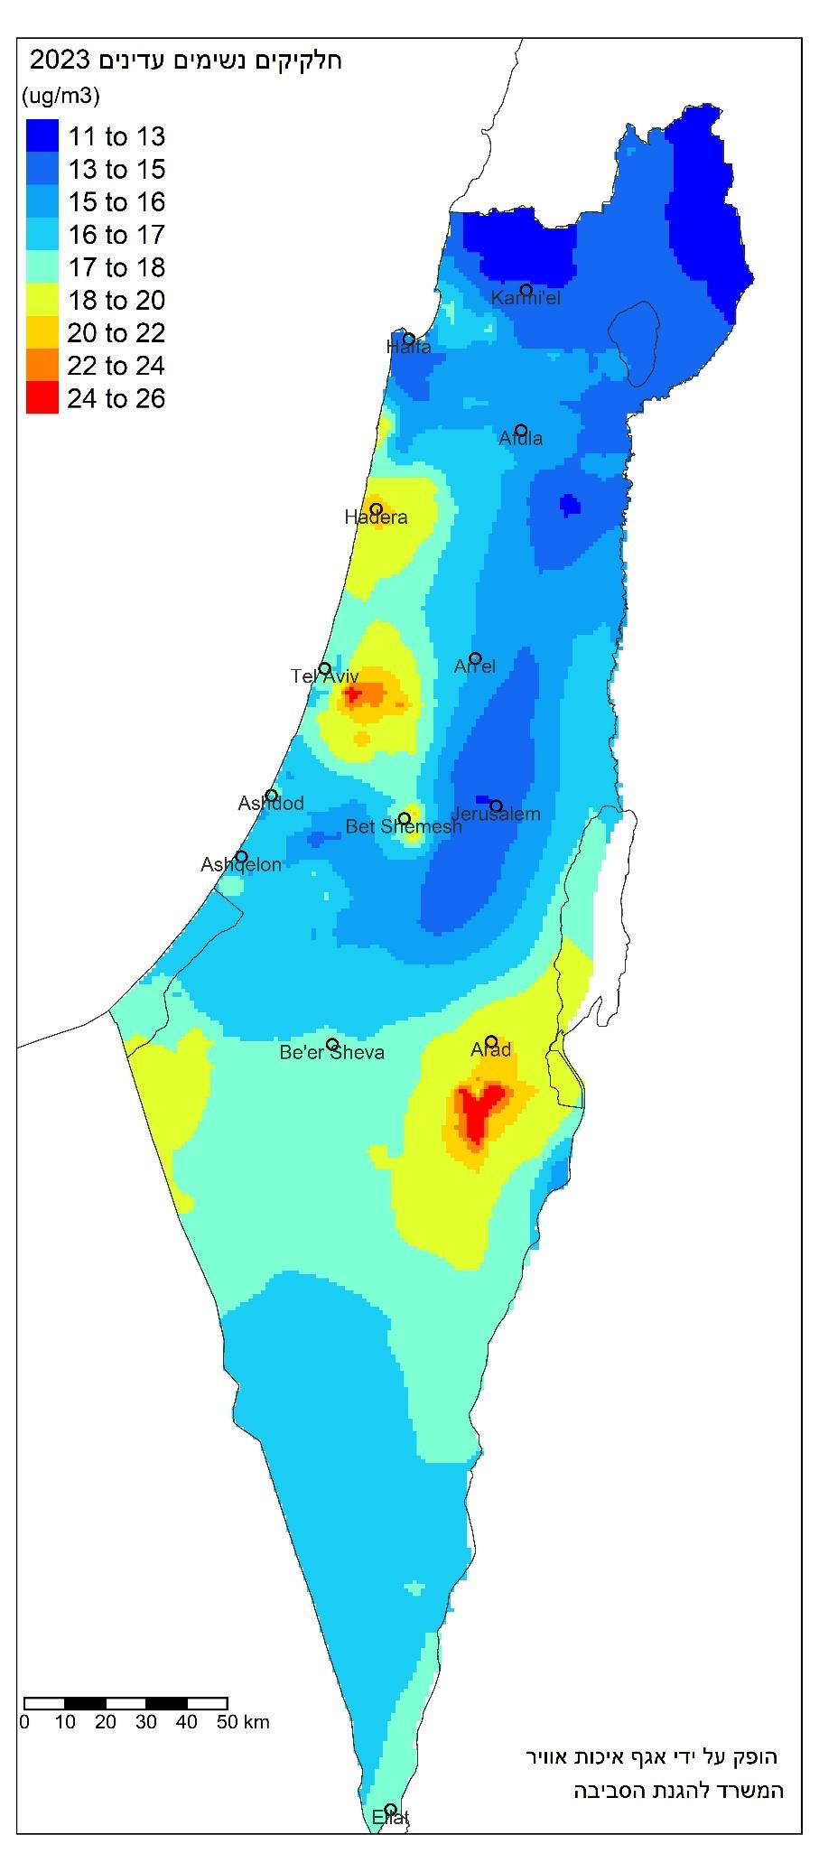

**Figure 3.1.1** *Annual mean concentrations of PM₂.₅ across Israel (Ministry of Environmental Protection [MOEP], 2023).*

According to MOEP (2023) (*Fig. 3.1.1*), average annual concentrations of PM₂.₅ in Northern Israel generally ranged between 13–17 µg/m³. Within the Haifa metropolitan area, levels were in the upper part of this range, reflecting combined effects of industrial activity, port operations, and dense traffic corridors.

Peripheral and rural areas of the Northern District (Upper Galilee, Golan) showed somewhat lower values, closer to 11–14 µg/ m³, consistent with their distance from major industrial and transport sources. Despite gradual national reductions in emissions since the late 2000s, these concentrations remain above the WHO guideline for PM₂.₅ (5 µg/m³ annual mean), indicating persistent public health relevance.

### PM₁₀



**Figure 3.1.2** *Annual mean concentrations of PM10 across Israel (MOEP, 2023).*

The 2023 MOEP annual report shows that ambient concentrations of PM₁₀ in Northern Israel were generally in the range of 23–32 µg/m³. Within the Haifa Bay industrial zone and its adjacent urban areas, values were at the higher end of this range, consistent with combined industrial and traffic sources. In the wider Northern District, including Karmiel and Afula, levels were somewhat lower, typically 20–26 µg/m³, reflecting less industrial density but with occasional influences from regional dust transport. Compared with the central and southern parts of the country, PM₁₀ concentrations in the North were moderate; however, they remain above the WHO annual guideline of 15 µg/m³, and exceedances are common during dust storm episodes.

### O3



**Figure 3.1.3** *Annual mean concentrations of ozone (O₃) across Israel (MOEP, 2023).*

As shown in *Figure 3.1.3*, O₃ concentrations in Northern Israel during 2023 were generally in the range of 60–80 µg/m³ (annual mean). In the Haifa metropolitan area, values were at the lower end (≈ 60–70 µg/m³), likely due to local O₃ titration by NOx from dense traffic and industrial sources.

In contrast, peripheral and rural areas of the Northern District, including parts of the Galilee and the Golan, reached 75–85 µg/m³, reflecting secondary formation and accumulation downwind of emission sources. Although lower than the high levels observed in Israel’s southern desert regions, these concentrations still exceeded the WHO guideline of 60 µg/m³ (8-hour mean) on many days, highlighting ***O₃*** as a relevant regional pollutant.

### SO2



**Figure 3.1.4** *Annual mean concentrations of sulfur dioxide (SO₂) across Israel (MOEP, 2023).*

As shown in *Figure 3.1.4*, SO₂ concentrations in 2023 were generally low across Northern Israel, typically ranging between 0.5–5 µg/m³ (annual mean). The Haifa metropolitan area displayed the highest values in the region, with localized elevations above 5 µg/m³, reflecting the influence of industrial emissions from the Haifa Bay zone.

Elsewhere in the Northern District — including Karmiel, Afula, and the Galilee highlands — SO₂ levels remained modest, generally below 2.5 µg/m³, consistent with the absence of major point sources. Compared with historical levels, current concentrations reflect substantial national reductions in industrial SO₂ emissions, although Haifa Bay continues to stand out as a relative hotspot.

### NOx



**Figure 3.1.5** *Annual mean concentrations of nitrogen oxides (NOx) across Israel (MOEP, 2023).*

As shown in *Figure 3.1.5*, NOx concentrations in 2023 were generally low across Northern Israel, with annual averages mostly within the 4–10 µg/m³ range. Within the Haifa Bay area, slightly higher values were observed, reflecting the influence of industrial emissions and heavy traffic flows through the metropolitan zone.

Elsewhere in the Northern District — including Karmiel, Afula, and peripheral Galilee areas — concentrations were consistently in the lower range (≤ 10 µg/m³). Compared with central Israel, where urban traffic produces localized hotspots, NOx levels in the North are moderate but still noteworthy in the Haifa industrial–urban corridor.

### NO2



**Figure 3.1.6** *Annual mean concentrations of nitrogen dioxide (NO₂) across Israel (MOEP, 2023).*

As shown in *Figure 3.1.6*, NO₂ concentrations in 2023 in Northern Israel ranged mostly between 3–12 µg/m³ (annual mean). The Haifa metropolitan area exhibited the highest values in the region, reaching up to 12–18 µg/m³ in localized zones, reflecting the combined impact of heavy traffic and industrial emissions in Haifa Bay.

In surrounding areas of the Northern District — including Hadera, Afula, and Karmiel — concentrations were lower, generally 3–6 µg/m³, consistent with smaller urban centers and reduced traffic density. Compared with central Israel, particularly the Tel Aviv metropolitan zone, NO₂ levels in the North are more moderate but still represent an important exposure in the Haifa urban–industrial corridor.

### CO



**Figure 3.1.7** *Annual mean concentrations of carbon monoxide (CO) across Israel (MOEP, 2023).*

As shown in *Figure 3.1.7*, CO concentrations in 2023 across Northern Israel were relatively low compared with other regions of the country, with most areas recording annual averages of 125–155 µg/m³. In the Haifa metropolitan area, slightly higher levels were observed, reaching 155–185 µg/m³, consistent with heavy traffic corridors and port activity.

Elsewhere in the Northern District, including Karmiel, Afula, and the Galilee periphery, CO concentrations were more modest, generally 125–135 µg/m³. By contrast, central Israel (particularly the Tel Aviv region) showed higher values, reflecting greater vehicular density. Overall, CO pollution in the North is less prominent than particulate matter or nitrogen oxides but remains relevant in the Haifa urban–industrial corridor.

## Summary

The available monitoring data (MOEP, 2023) confirm that residents of Northern Israel, and particularly the Haifa metropolitan area, are exposed to multiple ambient air pollutants at levels that in some cases exceed recommended health-based guidelines. While long-term emission reductions are evident, local hotspots remain for fine particles, nitrogen oxides, and sulfur dioxide, especially in the Haifa Bay industrial zone and along major transportation corridors.

These findings establish the environmental exposure context for the current study. In the following chapter, we examine the spatial distribution of LC cases in relation to this environmental background, alongside other established risk factors.

# Chapter 3.2. Clinical-Laboratory Data (Lung Cancer Diagnosis)

## Background

Unlike previous chapters, reviewing and summarizing data gathered by other researchers, ***chapter 3.2*** constitutes the **clinical-laboratory** part of our seminar work. Here, we analyse a dataset compiled by us specifically for this study and based on anonymized patient-level information. The purpose of this dataset is to test, in a local cohort, patterns repeatedly described in the literature — particularly the distribution of histopathological subtypes, PD-L1 expression, and key molecular alterations (e.g., EGFR, KRAS, BRAF). This dual approach allows us to connect broader environmental and epidemiological findings with concrete clinical data, thereby bridging population-level evidence and individual-level tumour characteristics.

## Objectives

The **objectives** of this clinical-laboratory analysis were threefold:

1. ***Molecular profiling*** — to characterize the prevalence of key molecular alterations in LC cases, including PD-L1 expression (via immunohistochemistry (IHC)), driver mutations (EGFR, KRAS, BRAF, MET, ALK, ROS1, ERBB2, RET, NTRK1/2/3; via next-generation sequencing (NGS)), and mismatch repair (MMR) genes (MLH1, PMS2, MSH2, MSH6; via polymerase chain reaction (PCR)).
2. ***Geographic mapping*** — to document the residential distribution of patients within the Israeli northern districts and evaluate spatial tendencies in case occurrence.
3. ***Demographic stratification*** — to categorize cases by ethnic origin and examine differences in clinical or molecular characteristics across groups.

These objectives aim to integrate histopathological, molecular, and demographic dimensions of LC to establish a robust foundation for subsequent evaluation of gene-environment interactions.

## Data Source

**Origin.** Individual electronic medical records (EMRs) of patients (whose lung biopsy and surgical material were diagnosed in the Department of Pathology of the Lady Davis Carmel Medical Center, Haifa) in the Ofek intra/interhospital medical informatics platform. The clinical-laboratory variables come from histopathology, IHC, and NGS testing and are used for descriptive and comparative analyses within the cohort. These patient‑level data were further overlapped with exposure metrics (see Chapter 3.1) to explore associations between ambient air pollution and tumour characteristics.

**Sample.** The 94 lung cancer cases managed at the Carmel Hospital in 2024-2025.

**Dataset.** Created through review of anonymized electronic medical records of 94 lung cancer patients at Carmel Medical Center and was processed and analysed in Python (pandas, matplotlib, seaborn, statsmodels). Twenty-one variables are available, covering demographics (age, sex, ethnic group, residential district, smoking history), histopathological diagnosis, and molecular biomarkers (PD-L1 expression, EGFR, KRAS, BRAF, MET, ALK, ROS1, NTRK, RET, ERBB2, MSI, TMB). The full raw data set is in Appendix A and is available upon individual request as a separate data file CarmelMC_LungCancer.xlsx.

## Data Dictionary (Clinical-Laboratory Variables)

In this study, variables are described according to a ***syntactical approach***, distinguishing only between numeric and character. Under this approach, the functional role of a variable (continuous, discrete count, binary flag, or categorical) is determined by its analytical use rather than by its storage type.

* ***id*** (numeric, nominal; identifier, not for analysis) - a clinical case's anonymized number
* ***sex*** (numeric, binary) - a patient's biological sex:
  + 0 = male
  + 1 = female
* ***age*** (numeric, continuous) - a patient's age (years) at the date of the lung biopsy or surgery
* ***ethnic*** (numeric, nominal) - a patient's presumed ethnic origin (subjective approximation based on the patient's name/surname evaluation and locality; not officially confirmed):
  + 0 = Jewish
  + 1 = Arab, not otherwise specified (NOS)
  + 2 = Arab (Druze)
  + 3 = Arab (Bedouin)
* ***locality*** (character, nominal) - a patient's place of residence (city, town, village, etc.)
* ***latitude*** (numeric, continuous) – a locality’s geographic latitude (decimal degrees)
* ***longitude*** (numeric, continuous) - a locality’s geographic longitude (decimal degrees)
* ***loc_popul*** (numeric, continuous) - a locality’s population size according to the Israeli Central Bureau of Statistics (2023) (number of peoples)
* ***district*** (numeric, binary) - Israeli administrative district to which a patient's locality belongs:
  + 0 = Haifa District
  + 1 = Northern District
* ***smoking*** (numeric, binary) - a patient's smoking status:
  + 0 = non-smoker (never smoked or quit > 10 years before the lung biopsy/surgery date)
  + 1 = smoker (current smoker or quit ≤ 10 years before the lung biopsy/surgery date)
* ***bx_date*** (numeric, ordinal) - date of the lung biopsy or surgery performed
* ***dx*** (numeric, nominal) - pathohistological diagnosis of lung cancer:
  + 0 = adenocarcinoma (ACA), NOS
  + 1 = mucinous ACA (MucACA)
  + 2 = squamous cell carcinoma (SCC)
  + 3 = neuroendocrine tumour (NET) (low-grade (typical carcinoid) or intermediate-grade (atypical carcinoid) neuroendocrine neoplasm)
  + 4 = neuroendocrine carcinoma (NEC) (high-grade neuroendocrine neoplasm (small cell lung cancer or large cell neuroendocrine carcinoma))
* ***pdl1*** (numeric, binary) - PD-L1 expression measured by TPS:
  + 0 = weak (TPS = 1-49%)
  + 1 = strong (TPS ≥ 50%)
* ***met*** (numeric, binary) - MET gene mutation status:
  + 0 = no mutation
  + 1 = mutation detected
* ***egfr*** (numeric, binary) - EGFR gene mutation status:
  + 0 = no mutation
  + 1 = mutation detected
* ***braf*** (numeric, binary) - BRAF gene mutation status:
  + 0 = no mutation
  + 1 = mutation detected
* ***kras*** (numeric, binary) - KRAS gene mutation status:
  + 0 = no mutation
  + 1 = mutation detected
* ***erbb2*** (numeric, binary) - ERBB2 (HER2) gene mutation status:
  + 0 = no mutation
  + 1 = mutation detected
* ***alk*** (numeric, binary) - ALK gene mutation status:
  + 0 = no mutation
  + 1 = mutation detected
* ***ros1*** (numeric, binary) - ROS1 gene mutation status:
  + 0 = no mutation
  + 1 = mutation detected
* ***ntrk*** (numeric, binary) - NTRK1/NTRK2/NTRK3 genes mutation status:
  + 0 = no mutation
  + 1 = mutation detected
* ***ret*** (numeric, binary) - RET gene mutation status:
  + 0 = no mutation
  + 1 = mutation detected
* ***msi*** (numeric, ordinal) - ***microsatellite instability (MSI)*** status of the tumour - instability of short tandem DNA repeats (***microsatellites***) of tumour cells, which results from abnormal function of one or more mismatch repair (MMR) genes (MLH1, PMS2, MSH2, and MSH6):
  + 0 = microsatellite stable (MSS) status
  + 1 = low microsatellite instability (MSI-L)
  + 2 = high microsatellite instability (MSI-H)
* ***tmb*** (numeric, continuous) - ***tumour mutational burden (TMB)*** - number of non-inherited mutations per million bases (megabase, Mb) of the investigated genomic sequence. TMB is strongly predictive of a patient's response to immune checkpoint inhibitor therapy, of overall as well as disease-specific survival - independently of cancer type, stage or grade.

## Data Preprocessing

The clinical-laboratory dataset comprised 94 anonymized patient records, each with a unique identifier. Data completeness was high, with only 0.6% of values missing overall. The missing values were left unaltered and excluded listwise from the relevant analyses. Continuous variables, including age (42-91 years of age) and TMB (0.95-27.1 mutations per Mb), were within plausible clinical ranges. Categorical variables (sex, smoking status, ethnic group, histological diagnosis, and molecular markers) contained only valid coded values as defined in the data dictionary. No structural errors or inconsistencies were detected.

The dataset was therefore considered reliable for descriptive, inferential, and spatial analyses.

## Methods

**Dataset variables and coding.** Categorical nominal and binary variables were coded numerically (0/1 for binary, 0…k for multi-category). Molecular markers were recorded as 0/1 (absent/present). Missing values occurred only where laboratory testing was not performed due to technical reasons; these were left unaltered and excluded listwise during analysis. TMB was analysed as a continuous variable (mutations per Mb), whereas MSI was treated as ordinal (MSS, MSI-L, MSI-H).

**Statistical analysis.** Descriptive statistics (means, medians, ranges for continuous variables; counts and percentages for categorical variables) were computed to characterize the study cohort. For comparisons, Fisher exact test was applied where cell counts were sparse; otherwise, Pearson Chi-square test was used. Continuous variables (e.g., age, TMB) were compared across groups using t-tests or non-parametric alternatives (Mann-Whitney U) as appropriate. Correlations between continuous variables were assessed with Pearson or Spearman correlation coefficients.

**Geospatial analysis.** It included mapping of patients’ residential localities within the Haifa District and Northern District and applying kernel density estimation (KDE) to visualize spatial clustering of cases. Locality-based aggregation was also performed to examine patterns of distribution across ethnic and administrative subdivisions.

**Software environment.** All analyses and visualizations were performed in Python programming language, using the pandas, matplotlib, seaborn, and statsmodels libraries.

## Analyses and Their Results

### Demographics of the Study Cohort

**Table 3.2.1** *Demographic characteristics of the study cohort of the lung cancer patients treated at the Carmel Medical Center*

| **Total, patients** | | 94 | 100 % |
| --- | --- | --- | --- |
| **Age, median (range)** | | 72 (42–91) years | |
| **Sex** | Female | 52 | 55.3 % |
| Male | 42 | 44.7 % |
| **Smoking** | Non-smoker | 48 | 51.1 % |
| Smoker | 46 | 48.9 % |
| **District** | Haifa | 37 | 39.4 % |
| Northern | 57 | 60.6 % |
| **Ethnicity** | Jewish | 64 | 68.1 % |
| Arab, NOS | 24 | 25.5 % |
| Druze | 5 | 5.3 % |
| Bedouin | 1 | 1.1 % |
| **Histopathology** | ACA, NOS | 63 | 67.0 % |
| SCC | 25 | 26.6 % |
| MucACA | 4 | 4.3 % |
| NEC | 2 | 2.1 % |

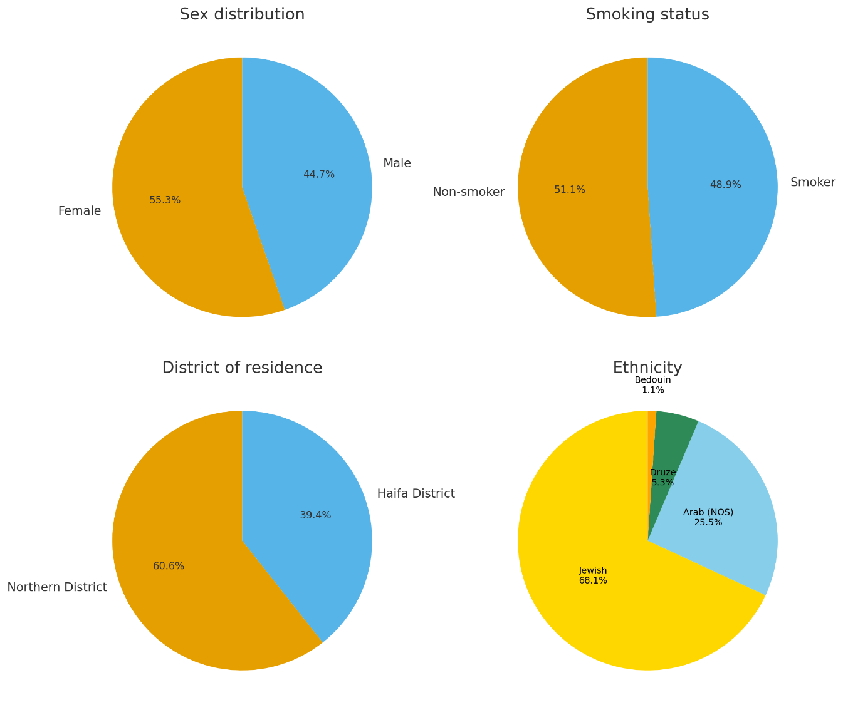

**Figure 3.2.1** Sex, smoking status, district of residence, and ethnic distribution of the study cohort.

The study cohort (*Table 3.2.1*, *Fig. 3.2.1*) consisted of 94 LC patients. The median age at diagnosis was 72 years (range: 42–91).

Sex distribution was slightly female-predominant (55.3% females, 44.7% males).

Smoking status was nearly balanced, with 51.1% non-smokers and 48.9% smokers.

Geographically, 39.4% of patients resided in the Haifa District, while 60.6% lived in the Northern District. Ethnically, the majority were Jewish (68.1%), followed by Arab (NOS) (25.5%), Druze (5.3%), and a small proportion of Bedouins (1.1%).

Overall, the cohort represents elderly, nearly balanced male/female population, predominantly Jewish, with a near-equal split of smokers vs non-smokers.

### Histopathological subtypes, biomarker distribution, and tumour mutational burden

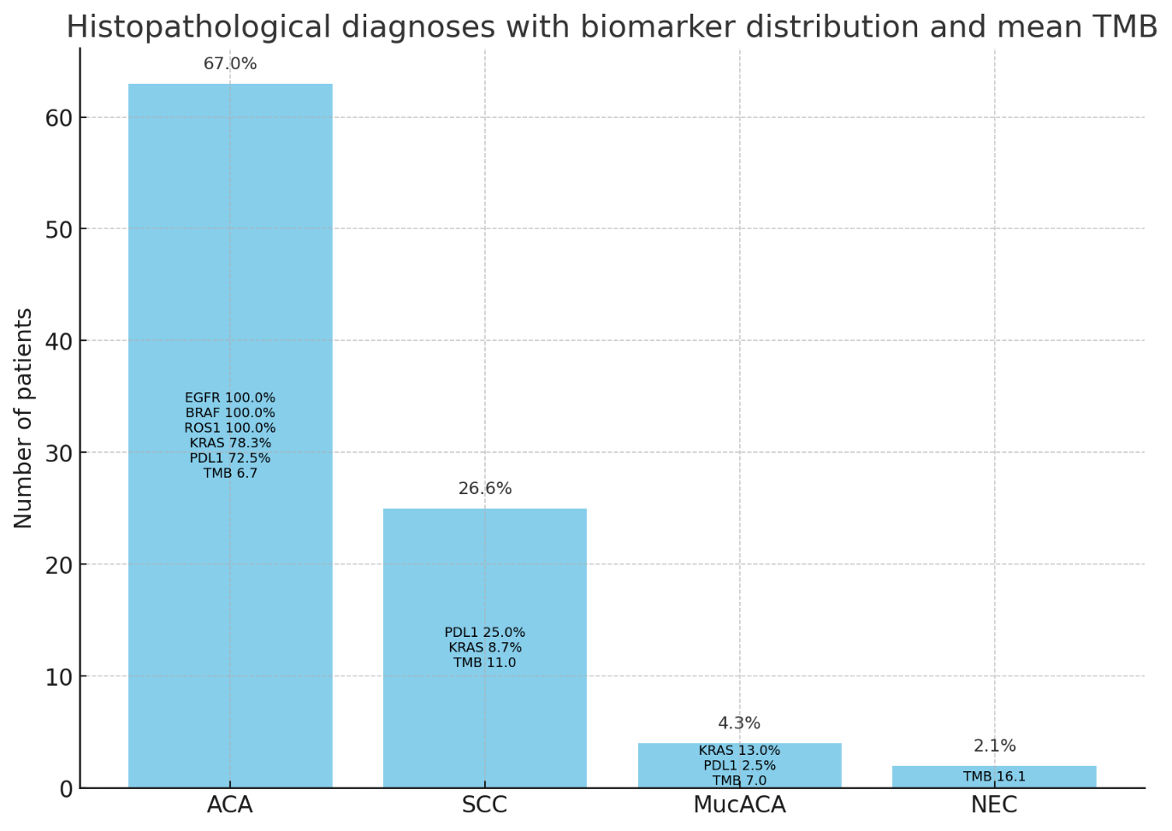

**Figure 3.2.2** *Histopathological diagnoses with biomarker distribution and mean tumour mutational burden in the study cohort.*

Analysis of the study cohort revealed that ***ACA, NOS*** was the most frequent histopathological subtype (67.0%), followed by SCC (26.6%), MucACA (4.3%), and neuroendocrine carcinoma (NEC) (2.1%). No patients were diagnosed with carcinoid tumours (NET) (*Fig. 3.2.2*).

Within these subgroups, biomarker profiles showed distinct patterns. In ACA, the majority of biomarker-positive cases were observed: EGFR, BRAF, and ROS1 alterations were exclusively present in adenocarcinomas, while KRAS and PD-L1 positivity were also concentrated in this subtype (78.3% and 72.5% of all positive cases, respectively). SCC cases showed lower proportions of PD-L1 (25.0%) and KRAS (8.7%) positivity. MucACA was characterized by KRAS (13.0%) and a small proportion of PD-L1 positivity (2.5%). NEC cases did not exhibit biomarker positivity in this cohort.

Mean TMB differed across histologies, ranging from 6.7 in ACA, through 11.0 in SCC and 7.0 in MucACA, to the highest average of 16.1 observed in NEC.

Overall, these findings highlight ***ACA*** as the dominant histological subtype and the main reservoir of biomarker positivity in the cohort, while SCC and rare histologies displayed more limited biomarker associations.

### Geographic distribution of lung cancer cases

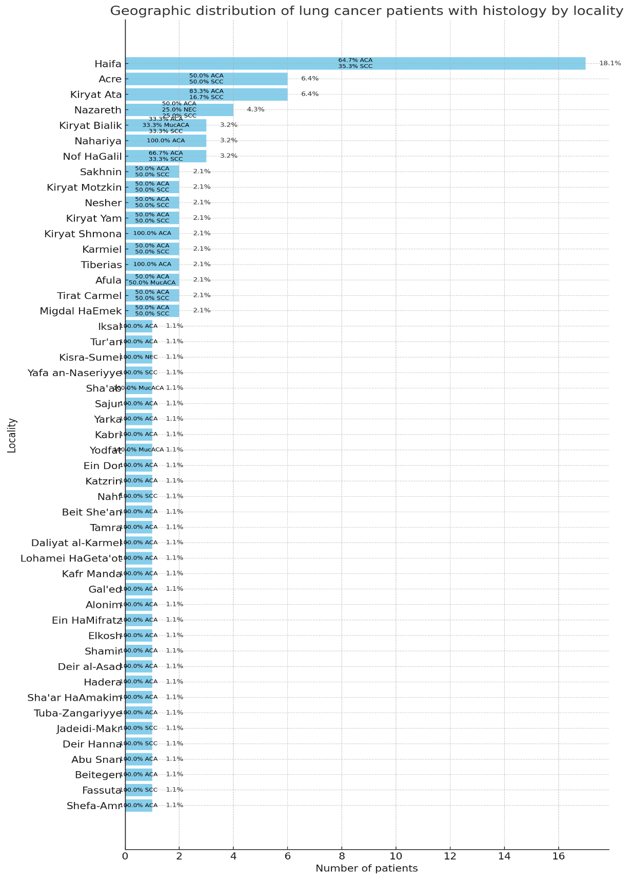

**Figure 3.2.3** *Geographic distribution of lung cancer patients by locality of residence, with histopathological composition shown within each bar.*

Analysis of the geographic distribution of cases revealed marked heterogeneity across the study region. As shown in *Figure 3.2.3*, the largest concentration of patients resided in Haifa (18.1% of the cohort), followed by Acre (6.4%), Kiryat Ata (6.4%), and Nazareth (4.3%). Several additional localities, including Kiryat Bialik, Nahariya, and Nof HaGalil, contributed 3.2% each. The remaining cases were dispersed across more than 40 smaller towns and villages, each representing ≤2.1% of the cohort.

Histopathological composition varied between localities. For example, Haifa patients were predominantly with ACA (64.7%), with a substantial fraction of SCC (35.3%). Acre cases split evenly between ACA and SCC, while Nazareth showed a more mixed profile, including ACA, SCC, and NEC. Some smaller localities were represented entirely by single histological types (e.g., 100% ACA in Tiberias).

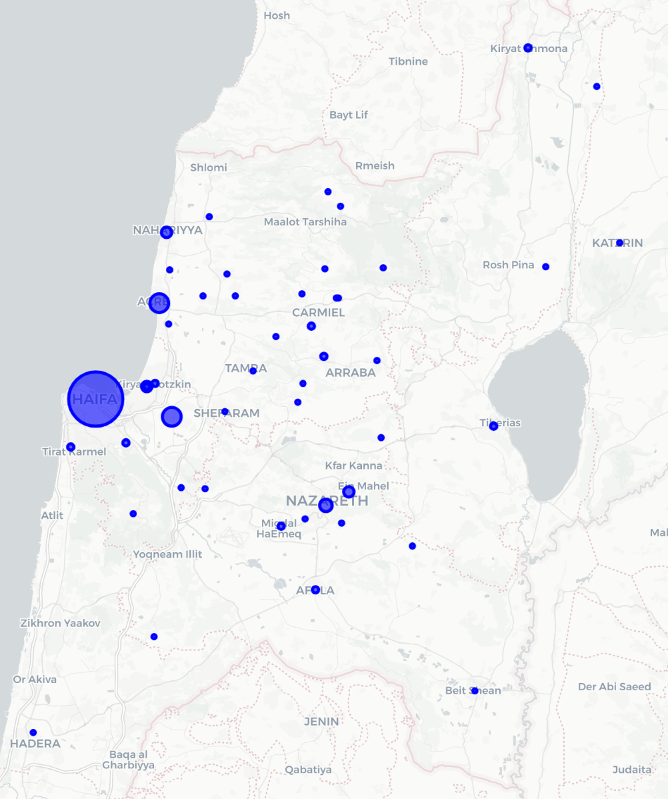

**Figure 3.2.4** *Bubble map of lung cancer cases across Northern Israel by locality of residence.*

The bubble map (*Fig. 3.2.4*) provides a geographic overview of case distribution across the Haifa and Northern districts. Larger bubbles correspond to higher patient counts, with ***Haifa*** clearly emerging as the dominant cluster. Additional concentrations are evident along the coastal plain (Acre, Nahariya, Kiryat Ata, Kiryat Bialik) and in inland centres such as Nazareth, Nof HaGalil, and Afula. Peripheral settlements in the Upper Galilee and Golan subdistrict contributed only isolated cases.

Together, these visualisations highlight the predominance of urban centres, particularly the Haifa metropolitan area, in the cohort’s spatial distribution. The observed non-uniformity provides a descriptive foundation for subsequent spatial analyses aimed at testing the statistical significance of apparent clustering.

An important limitation concerns potential referral bias. Since the dataset derives from patients managed at Carmel Medical Center, the density of cases in the city of Haifa and close to it may partly reflect hospital catchment patterns rather than underlying environmental risk. Patients residing in more distant areas may have been diagnosed and treated in other regional hospitals, and thus are underrepresented here. Consequently, the observed hotspot in the Haifa metropolitan area could be influenced by healthcare access and referral practices in addition to true disease distribution.

A possible counterbalance is that molecular biomarker testing has become routine relatively recently and is more consistently available in tertiary centres such as Carmel; thus, patients across Northern Israel may have been preferentially referred to Haifa for advanced diagnostic workup. However, this remains a tentative consideration rather than a demonstrable fact, and referral bias should still be borne in mind when interpreting the observed geographic distribution.

***Kernel density estimation and spatial clustering of lung cancer cases***

***KDE*** is a spatial smoothing technique that transforms individual case coordinates into a continuous surface of case intensity, thereby visualizing potential hotspots of disease occurrence. We applied KDE to the LC case dataset to explore patterns of spatial heterogeneity across the Haifa District and Northern District.

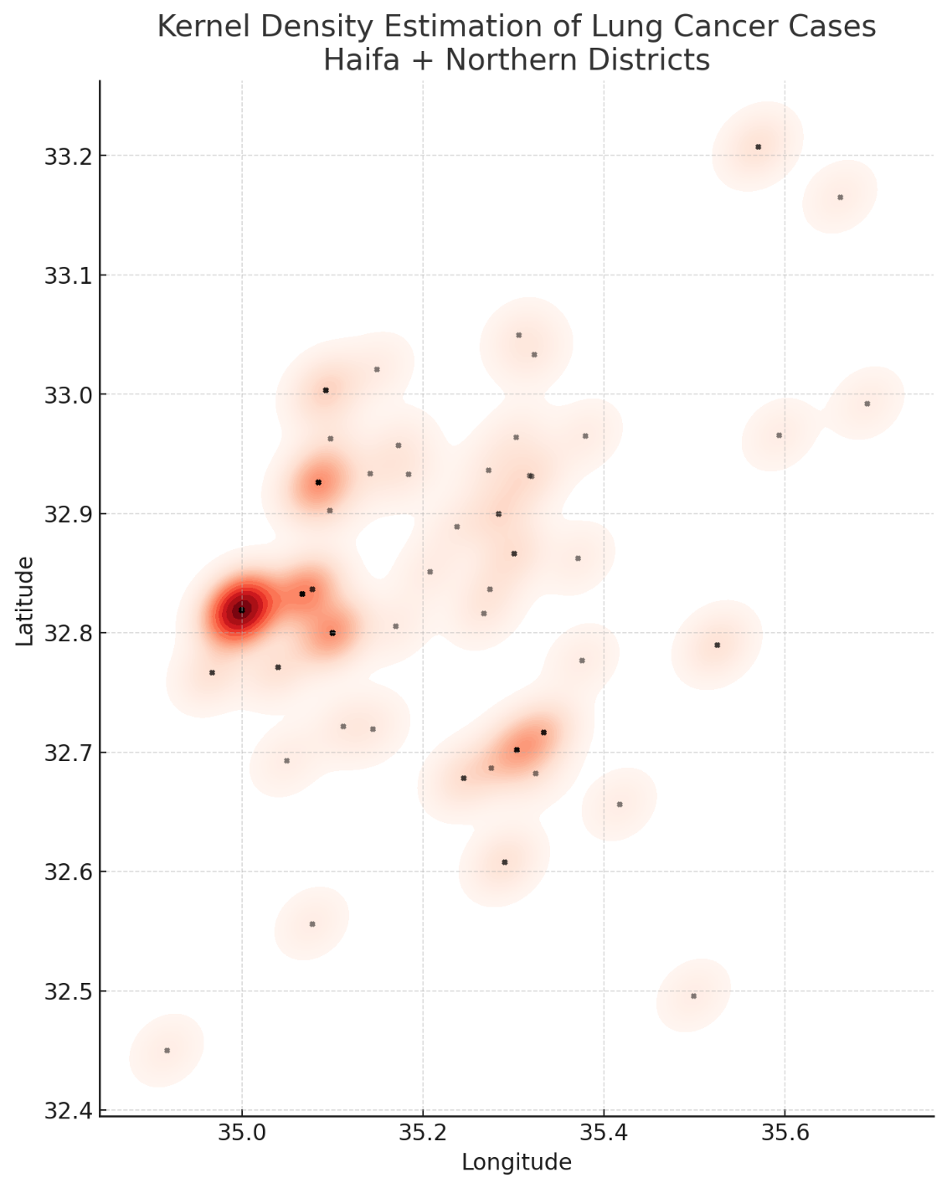

**Figure 3.2.5a** *Kernel density estimation map of lung cancer cases across both the Haifa District and Northern District (unadjusted, absolute counts).* The red shaded areas indicate higher estimated case densities. Localities are shown as black dots.

*Figure 3.2.5a* presents the unadjusted KDE, in which each case is weighted equally. Here, the most prominent hotspot is centered on Haifa and its metropolitan surroundings (Krayot, Tirat Carmel), with additional density peaks in Acre and Nahariya along the coastal plain. This picture mirrors the absolute number of cases and strongly correlates with large urban populations. Urban areas naturally generate more cases simply because more people live there, creating a strong bias in the visualization.

To address this, we constructed a population-adjusted KDE by weighting each case inversely to the size of its locality population (*Figure 3.2.5b*). This adjustment controls for the baseline population denominator, allowing the heatmap to highlight areas with elevated relative intensity of LC cases rather than just absolute counts.

The resulting spatial pattern differs markedly from the unadjusted version. While Haifa remains visible, its relative dominance is reduced. Instead, new areas emerge with elevated relative intensity: Nazareth and its surrounding localities; Afula and adjacent Jezreel Valley localities; Upper Galilee towns. By contrast, Nahariya and Acre lose much of their hotspot appearance after adjustment.

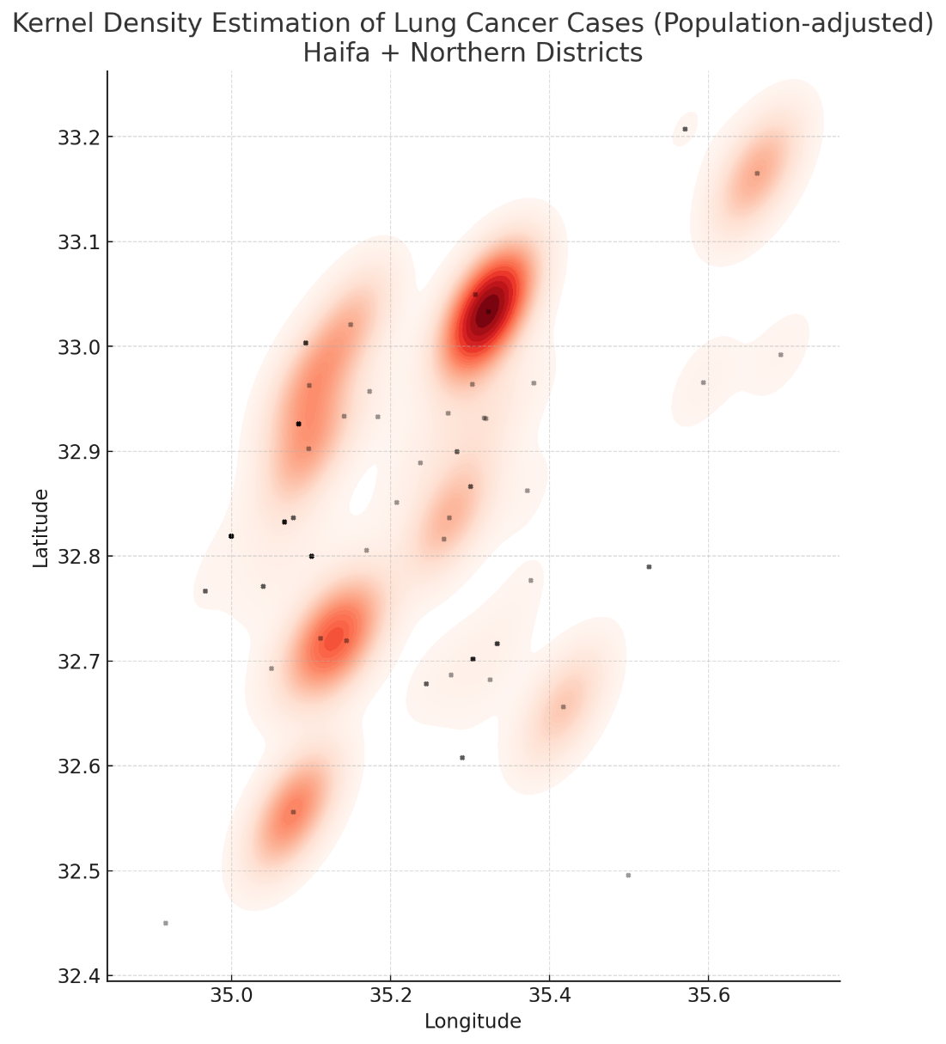

**Figure 3.2.5b** *Kernel density estimation map of lung cancer cases across both the Haifa District and Northern District (population-adjusted, relative risk intensity).*

Taken together, the comparison between the two maps illustrates the methodological importance of incorporating population denominators in spatial analyses. The adjusted KDE provides a more valid basis for subsequent exploration of spatial clustering and potential environmental determinants.

***KDE*** serves here as an exploratory tool: it illustrates spatial heterogeneity and suggests clustering patterns, but it does not establish statistical significance. These descriptive results point to geographic gradients that may be related to environmental exposures and justify further analytic testing in subsequent steps of the analysis. In the following analyses, we move from this exploratory visualization toward formal statistical testing of spatial clustering and associations with environmental exposures.

### Statistical Testing of Spatial Clustering

While kernel density estimation provided a descriptive visualization of case intensity across the Haifa and Northern districts, it does not indicate whether the observed spatial patterns are unlikely to have arisen by chance. To formally assess clustering, we applied ***statistical tests of spatial autocorrelation***. These methods evaluate whether neighbouring localities exhibit more similar case frequencies than would be expected under a random distribution.

Thus, we computed Moran I statistic on LC incidence across localities, using case counts standardized by locality population to obtain incidence per 100,000. Spatial weights were constructed based on geographic proximity of localities. Moran I measures the degree of global clustering, where values near 0 indicate randomness, positive values indicate clustering, and negative values indicate dispersion.

The analysis produced the following output:

* Permutation test p-value = 0.001.
* Moran’s I value could not be stably estimated (NaN) due to extreme incidence rates in very small-population localities.

Despite the instability of the exact Moran’s I coefficient, the permutation test strongly indicates that the observed spatial pattern is not random but exhibits significant clustering.

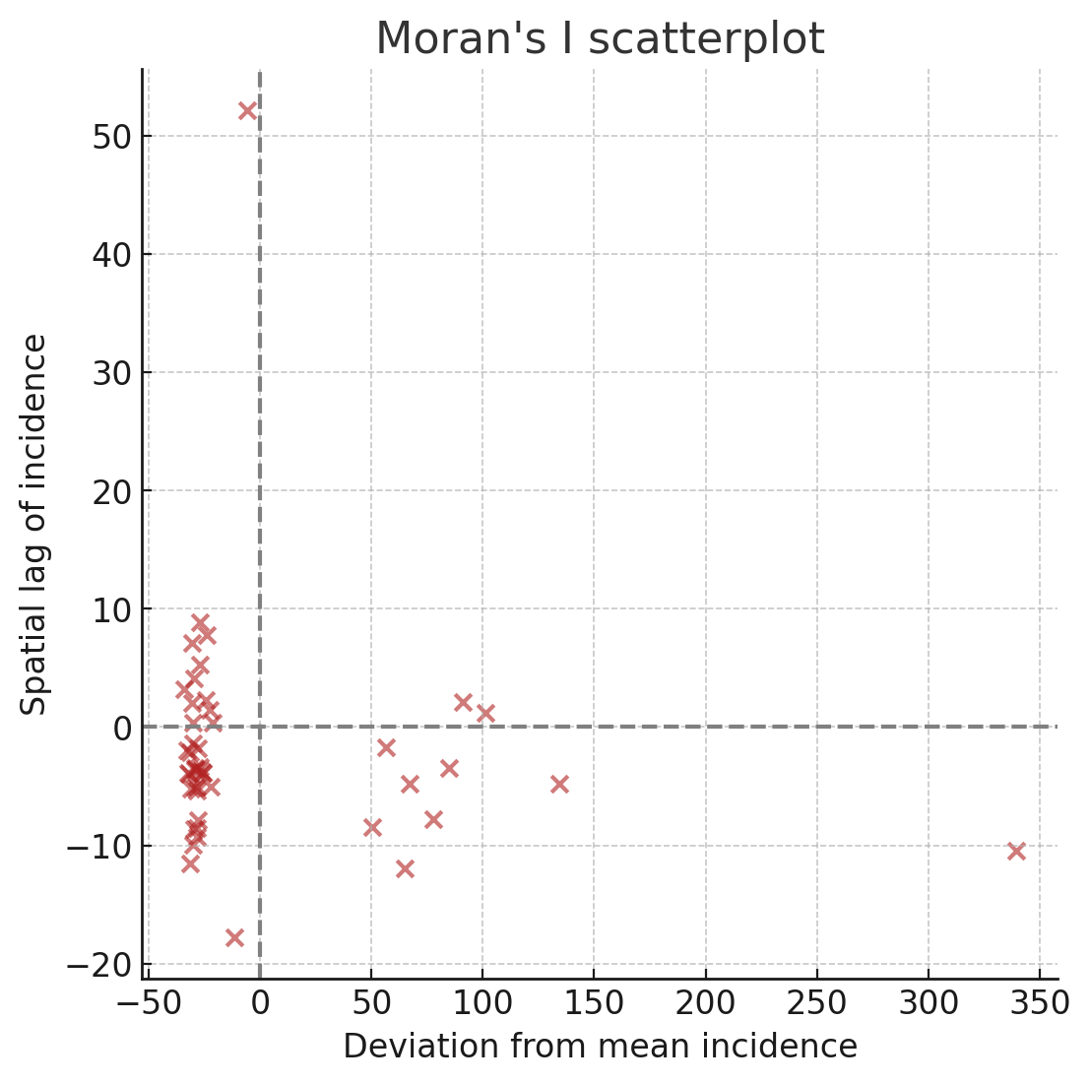

**Figure 3.2.6** *Moran scatterplot of lung cancer incidence across Northern Israel.*

*Figure 3.2.6* presents the Moran scatterplot, where each point represents a locality. The x-axis shows the deviation of a locality’s incidence from the mean, and the y-axis shows the spatial lag (average of its neighbours). Points in the upper right quadrant represent localities with high incidence surrounded by high-incidence neighbours (***hotspots***), while those in the lower left quadrant represent low-incidence clusters (***coldspots***).

Taken together, the results confirm that LC incidence in the Northern Israel is spatially clustered rather than randomly distributed. Visual comparison of *Figures 3.2.4* (locality map) and *3.2.5b* (population-adjusted KDE) suggests that clustering is driven primarily by inland concentrations in Nazareth and surrounding towns, Migdal HaEmek, and the Jezreel Valley (Afula region), with additional contributions from Upper Galilee localities such as Carmiel and Arraba. Coastal cities such as Haifa, Acre, and Nahariya appear less influential once population size is accounted for.

These findings validate the descriptive KDE patterns and justify the application of local indicators of spatial association (LISA) in the next step, to pinpoint which specific localities form statistically significant hotspots.

### Local indicators of spatial association

The global Moran I analysis confirmed that lung cancer incidence across Northern Israel is spatially clustered rather than randomly distributed. To identify where these clusters occur, we applied ***LISA***, which evaluate whether each locality shows unusually high or low incidence compared to its neighbours.

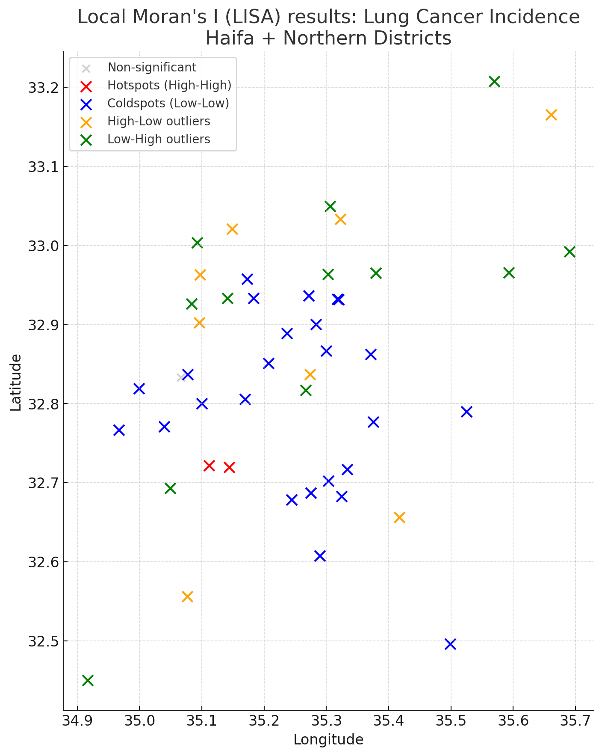

**Figure 3.2.7** *Local Moran’s I (LISA) analysis of lung cancer incidence across the Northern Israel.*

*Figure 3.2.7* presents the LISA results. Localities are categorized into four groups:

* Hotspots (high–high): localities with elevated incidence surrounded by other high-incidence localities.
* Coldspots (low–low): localities with low incidence surrounded by other low-incidence localities.
* High–low outliers: high-incidence localities situated among low-incidence neighbours.
* Low–high outliers: low-incidence localities situated among high-incidence neighbours.

**Table 3.2.2** *Localities classified as high–high hotspots or high–low outliers (LISA analysis)*

|  |  |  |  |  |
| --- | --- | --- | --- | --- |
| **Locality** | **Population, persons** | **Cases (n)** | **Incidence (per 100,000)** | **Cluster type** |
| Alonim | 733 | 1 | 136.4 | hotspot (high–high) |
| Sha'ar HaAmakim | 794 | 1 | 125.9 | hotspot (high–high) |
| Ein Dor | 1,168 | 1 | 85.6 | high–low outlier |
| Ein HaMifratz | 885 | 1 | 113.0 | high–low outlier |
| Elkosh | 267 | 1 | 374.5 | high–low outlier |
| Gal’ed | 590 | 1 | 169.5 | high–low outlier |
| Kabri | 1,089 | 1 | 91.8 | high–low outlier |
| Lohamei HaGeta’ot | 978 | 1 | 102.2 | high–low outlier |
| Shamir | 833 | 1 | 120.0 | high–low outlier |
| Yodfat | 1,000 | 1 | 100.0 | high–low outlier |

*Table 3.2.2* summarises the hotspots and high-low outliers.

The analysis highlights a set of inland hotspots, particularly in and around Nazareth and Migdal HaEmek, as well as parts of the Jezreel Valley (Afula region). These areas show consistently higher LC incidence than expected given their population size, and their clustering suggests the presence of shared risk factors.

In contrast, the Upper Galilee and Golan rural localities appear predominantly as coldspots, with low incidence and neighbouring areas also at low levels. Haifa itself emerges as a high-incidence locality but primarily in the form of a high–low outlier, indicating that its elevated incidence does not extend consistently to surrounding towns once population adjustment is taken into account. Coastal towns such as Acre and Nahariya similarly lose prominence relative to the inland clusters.

These results refine the interpretation of the KDE maps by demonstrating that spatial clustering is driven less by the largest cities and more by inland towns where incidence appears disproportionately elevated. The identification of statistically significant hotspots provides a concrete basis for subsequent investigation of potential environmental exposures or socio-demographic risk factors concentrated in these subregions.

### Limitations and potential confounders

While the analyses above establish that LC incidence in the Northern Israel is spatially clustered, several important potential confounders must be considered. Most importantly, ***smoking*** is a dominant risk factor for LC, and differences in smoking prevalence between localities may contribute to the observed geographic gradients. In addition, ***ethnicity*** plays a significant role in shaping both smoking behaviours and access to healthcare, and also is an integral part of the study’s framework.

These factors will be explicitly addressed in subsequent analyses, by stratifying or adjusting the spatial distribution of LC cases according to smoking status and ethnic group. Accounting for these individual-level risk factors is essential in order to disentangle true environmental effects from population composition differences.

### Smoking As a Potential Confounder

While the previous analyses demonstrated statistically significant clustering of LC cases, it is critical to assess whether this pattern may be partly explained by differences in smoking prevalence across localities. Smoking is the strongest established risk factor for LC, and differences in smoking prevalence between localities could confound the observed geographic clustering of cases. To evaluate this possibility, we first visualized the spatial distribution of smokers in the study population.

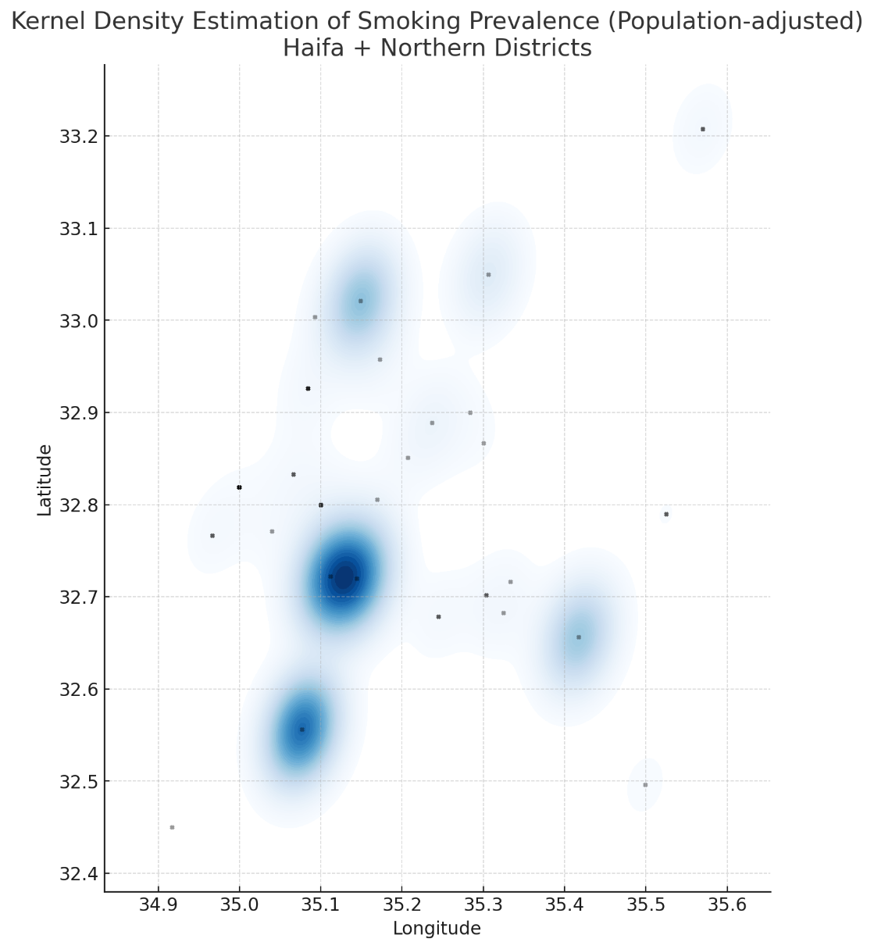

**Figure 3.2.8** Population-adjusted kernel density estimation of smoking prevalence across the Haifa District and Northern District.

*Figure 3.2.8* presents a population-adjusted KDE of smoking prevalence across the Haifa and Northern districts. The map shows inland foci of elevated smoking prevalence, particularly around Nazareth and Migdal HaEmek, as well as the Jezreel Valley (Afula region). The coastal corridor, including Haifa, Acre, and Nahariya, appears less prominent once population size is taken into account.

Comparison of this distribution with the lung cancer incidence KDE (*Fig. 3.2.5b*) reveals a notable degree of overlap. Both maps highlight the Nazareth–Migdal HaEmek region and Afula as areas of concern, suggesting that smoking prevalence could be contributing to the apparent clustering of LC cases. In contrast, comparison with the unadjusted incidence KDE (Figure 3.2.5a) shows little alignment: smoking prevalence does not explain the dominance of coastal urban centres in the crude case distribution. This discrepancy underscores the importance of population adjustment before interpreting clustering patterns.

To formally test whether smoking explains the observed clustering, we conducted stratified spatial autocorrelation analyses using Moran’s I. When LC cases were examined among smokers only, Moran’s I was 0.026 (p = 0.725), indicating no significant clustering. Similarly, among non-smokers only, Moran’s I was –0.032 (p = 0.626), again not significant. In other words, the statistically significant clustering observed in the combined dataset (Moran’s I p = 0.001) disappeared once analyses were stratified by smoking status.

Taken together, these findings indicate that ***smoking*** acts as a true confounder in the spatial distribution of LC cases. The clustering signal seen in unadjusted analyses is largely attributable to the uneven distribution of smoking prevalence across towns. Although environmental exposures may still contribute, any further spatial analysis must incorporate smoking to avoid biased conclusions.

### Synthesis and Interpretation

The analyses presented in Chapter 3.2 demonstrate both the promise and the pitfalls of spatial epidemiology. At first glance, crude mapping of LC cases suggested striking geographic gradients, with apparent clustering in the Haifa metropolitan area and other large towns. However, as successive sources of bias were addressed, the picture changed substantially.

Adjustment for population size showed that much of the apparent clustering was an artifact of larger urban centers, rather than elevated risk. Consideration of referral patterns highlighted the potential role of healthcare access in shaping observed distributions. Finally, stratification by smoking status revealed that the statistically significant clustering detected in the crude dataset disappeared when smoking was accounted for. This indicates that smoking functions as a true confounder, explaining much of the observed spatial heterogeneity.

Taken together, these findings underscore a critical methodological lesson: apparent geographic clusters of disease cannot be interpreted at face value. Without careful adjustment for denominators and confounders, crude maps risk overstating environmental effects. The strength of the present work lies not in identifying a novel environmental hotspot, but in demonstrating how rigorous analysis can overturn superficial impressions.

More broadly, this exercise illustrates how the true beauty of data analysis lies in its inherent unpredictability: robust research does not aim to confirm preliminary expectations, but to follow where carefully prepared data lead. By embracing this unpredictability, investigators can reach conclusions that are less biased and more faithful to the evidence. In the present work, the finding that apparent clustering dissolves once confounders are accounted for exemplifies this principle. Rather than weakening the analysis, it strengthens the scientific value of the study by demonstrating how evidence, not assumption, must guide interpretation.

### Ethnicity as a potential determinant

Although the spatial clustering of LC cases in the Northern Israel largely disappeared after adjustment for population size and smoking, ***ethnicity*** remains an important factor to consider. Ethnic affiliation is closely linked to both smoking prevalence and LC risk through cultural norms, occupational exposures, socioeconomic conditions, and healthcare access.

Accordingly, in this subsection we examine the distribution of LC cases and smoking prevalence by ethnic groups within the study population. The aim here is not to identify new geographic clusters, but to explore whether differences between different ethnic populations may help explain the patterns observed in the earlier analyses. By shifting the focus from where clusters occur to who is affected, we address ***ethnicity*** as a key determinant that interacts with smoking and potentially with environmental exposures.

**Table 3.2.3** *Lung cancer cases and smoking prevalence by ethnic group*

|  |  |  |  |  |
| --- | --- | --- | --- | --- |
| **Ethnicity** | **Cases (n)** | **% of total cases** | **Smokers (n)** | **Smoking prevalence among the cases (%)** |
| Jewish | 64 | 68.1 | 34 | 53.1 |
| Arab, NOS | 24 | 25.5 | 12 | 50.0 |
| Druze | 5 | 5.3 | 0 | 0 |
| Bedouin | 1 | 1.1 | 0 | 0 |

*Table 3.2.3* presents the distribution of cases and smoking prevalence by ethnic group. The majority of cases in the dataset were Jewish (68.1%), followed by Arab ones (25.5%). Very few cases were observed among Druzes (5.3%) or Bedouins (1.1%). Smoking prevalence among Jewish and Arab cases was similar, at 53.1% and 50.0% respectively, with no smokers recorded among Druze or Bedouin cases.

To evaluate whether smoking prevalence differed significantly between Jewish and Arab cases, a chi-square (χ²) test of independence was performed. The test yielded χ² = 0.0005 with p = 0.983, indicating no statistically significant difference. This suggests that, within the present dataset, ethnicity does not exert an independent influence on smoking status among LC cases.

Taken together, these findings imply that ethnicity does not directly explain the spatial clustering of LC cases observed in crude analyses. Its role is more likely indirect, reflecting the settlement patterns of different groups and their overlap with smoking prevalence. The data therefore reinforce the conclusion that ***smoking***, rather than ethnicity itself, is the primary confounder of the apparent geographic gradients in LC incidence.

## Summary

The analyses in this chapter illustrate how apparent spatial clustering of LC cases in the Northern Israel is progressively reshaped when key sources of bias and confounding are addressed. Crude mapping suggested marked case concentrations in urban centers, but this pattern was shown to reflect referral bias and population size rather than excess risk. KDE and global clustering tests initially indicated statistically significant spatial autocorrelation, yet these signals disappeared once smoking status was considered. Examination of ethnicity further demonstrated that Jewish and Arab cases had nearly identical smoking prevalence, with no significant differences detected.

Taken together, the evidence indicates that the apparent geographic clustering of LC cases is explained rather by the uneven distribution of smoking and population demographics across localities. The scientific value of this analysis lies not in identifying a novel environmental hotspot, but in demonstrating how rigorous adjustment can overturn superficial impressions and prevent misleading conclusions. Chapter 3.2 thus provides a cautionary lesson in spatial epidemiology: robust analysis requires disentangling true risk from artifacts of healthcare access, population structure, and behavioural confounders.

# Chapter 3.3. Cross-Synthesis of Environmental and Clinical-Laboratory Data

The purpose of this chapter was to integrate the environmental exposure information (air pollution data) presented in Chapter 3.1 with the clinical-laboratory findings on LC diagnosis described in Chapter 3.2. Such a cross-synthesis—sometimes referred to as ***spatial overlay***—can highlight whether geographic gradients of pollutant concentrations correspond with spatial patterns of disease occurrence. Although this approach is common in environmental epidemiology, it is methodologically demanding and often limited by cohort size, measurement resolution, and multiple potential confounders.

## Approach Applied

The environmental data (air pollution by NO₂, other NOx, SO₂, O₃, CO, PM₁₀, and PM₂.₅) were mapped using interpolation and visualization techniques described in Chapter 3.1. Clinical-laboratory data were mapped by patient residence (locality-based aggregation) and by KDE as outlined in Chapter 3.2. For the cross-synthesis, these two sets of spatial layers were theoretically overlaid to examine potential geographic correspondence between areas of higher pollutant concentrations and areas of LC case accumulation. No additional statistical models were applied beyond the descriptive and spatial procedures already presented.

## Findings and Observations

The overlay of pollutant concentration maps with LC case distribution did not reveal any statistically significant geographic overlap. While descriptive inspection suggested minor variations between localities, these differences were not consistent or strong enough to indicate clustering. In other words, areas with higher modelled air pollution levels did not systematically correspond to areas with greater densities of LC cases in this cohort. This outcome reflects the limitations of sample size and spatial resolution and suggests that within the current study population no discernible spatial association could be confirmed.

## Interpretation and Implications

The absence of clear spatial correspondence between the modelled air pollution and LC case density does not imply that environmental exposures are irrelevant. Rather, it underlines the multifactorial nature of LC aetiology, where genetics, smoking, occupational factors, and long-term cumulative exposures interact in complex ways. The relatively small sample size and the limited resolution of both clinical and environmental data constrained the ability to detect subtle geographic patterns. Still, conducting this cross-synthesis adds methodological value by demonstrating the integration of exposure and health data within a single framework. Future studies with larger cohorts, longer follow-up, and finer spatial monitoring could provide more conclusive insights.

## Summary

In summary, while the cross-synthesis of environmental and clinical-laboratory data in this cohort did not reveal a significant spatial correspondence, the exercise highlights both the potential and the challenges of such integrative approaches. These findings, together with the results from Chapters 3.1 and 3.2, provide the basis for a broader interpretation in the following discussion, where methodological strengths, limitations, and implications for public health will be considered.

# Part IV. DISCUSSION

# Interpretation of Key Findings

The data analysis demonstrated that LC cases in the Northern Israel cohort were distributed unevenly across localities, with apparent concentrations in urban centres. However, these patterns largely dissolved once population size and smoking status were accounted for, indicating that the observed spatial clustering was driven by confounding factors rather than environmental exposures. The cross-synthesis of the environmental and clinical-laboratory data further confirmed that the pollutant concentration maps and LC case distribution did not show systematic geographic overlap. Biomarker analysis highlighted ACA as the predominant histological subtype and the main reservoir of actionable genomic alterations, consistent with international patterns. Collectively, the findings underscore that ***smoking*** remains the strongest determinant of spatial heterogeneity in this dataset, while ***environmental exposures*** could not be demonstrated as independent drivers within the limits of the current cohort.

# Comparison with existing literature

The results of this work partly align with prior research from Haifa Bay and Northern Israel, which has documented elevated cancer risks near industrial complexes (Kayyal-Tarabeia et al., 2022; Eitan et al., 2010; Portnov et al., 2008). However, unlike these larger registry-based studies, the present cohort did not reveal a clear excess of LC cases in proximity to industrial or traffic-related hotspots once smoking and population size were considered. This divergence is most likely due to the smaller sample size, hospital-based design, and limited temporal coverage of the current dataset. At the clinical-laboratory level, the predominance of ACA and the frequency of EGFR, KRAS, and PD-L1 alterations mirror findings from broader international literature (Mesquita et al., 2025; Su et al., 2025). Thus, while the study replicates global clinical-laboratory patterns, its environmental component provides a cautionary note: ecological signals observed in large-scale studies may not be detectable in smaller, local datasets without long-term exposure assessment and rigorous control for confounders.

# Public Health and Clinical Implications

The study reinforces ***smoking*** as the dominant determinant of LC in Northern Israel, emphasizing the need for continued tobacco control and targeted cessation programmes. Although no independent spatial association with ambient air pollution was demonstrated, the persistence of pollutant levels above WHO guidelines in the Haifa region suggests ongoing relevance for long-term monitoring and preventive policy. Clinically, the high proportion of actionable biomarkers supports integration of molecular testing into routine diagnostics to enable precision therapy. Together, these findings highlight the dual importance of reducing behavioural risk factors and strengthening personalized treatment pathways.

# Limitations

Several limitations should be acknowledged:

1. The clinical-laboratory dataset was hospital-based and may be affected by referral bias, limiting generalizability to the wider population.
2. The sample size was modest (94 cases only), reducing statistical power for detecting environmental effects or subgroup differences.
3. The air pollution exposures were assessed from regional monitoring and interpolation rather than individual-level measurements, leading to potential exposure misclassification.
4. Important confounders, - such as detailed smoking history, occupational exposures, and socioeconomic status, - could not be fully adjusted.

These limitations constrain causal inference but do not cancel the overall methodological value of the study.

# Part V. CONCLUSIONS AND RECOMMENDATIONS

# Summary of observed patterns

This seminar work examined the interplay between environmental exposures and genomic alterations in LC within the Northern Israel cohort. Ambient air pollution data confirmed that residents of the Haifa metropolitan area are exposed to multiple pollutants above recommended guidelines. Clinical-laboratory analysis showed ***ACA*** as the predominant histology and the main reservoir of biomarker positivity, with EGFR, KRAS, and PD-L1 as the most frequent alterations. Spatial analyses initially suggested clustering of cases, but these patterns were explained by smoking prevalence and population size rather than independent environmental effects. The cross-synthesis attempts concerning the clinical and environmental layers did not reveal significant geographic overlap.

# Recommendations

Based on these findings, the following priorities emerge:

1. Tobacco control should remain the central preventive strategy, with special attention to communities where smoking prevalence is highest.
2. Environmental monitoring in Haifa Bay and Northern Israel needs to be sustained and refined, with greater spatial resolution to detect local variations.
3. The development of integrated databases that link air quality, cancer registry, and hospital records would enable stronger analytic frameworks.
4. Comprehensive molecular profiling should be ensured for all LC patients, allowing effective use of targeted therapies and immunotherapy.
5. Future studies should expand to larger population-based cohorts in order to increase statistical power for assessing environmental effects.
6. Collection of individual-level data on smoking, occupation, and socioeconomic status is essential to reduce residual confounding.
7. Closer collaboration between environmental authorities, clinicians, and epidemiologists to translate evidence into effective prevention and policy.

Future research combining larger population-based cohorts, detailed individual exposure data, and genomic information will be essential to clarify gene–environment interactions in lung carcinogenesis.

* * *

In conclusion, this seminar work demonstrates both the potential and the limitations of integrating environmental and genomic data in the study of lung cancer. While no independent spatial link with air pollution was established, the analysis highlights smoking as the dominant determinant in this cohort and confirms the clinical relevance of molecular profiling. Beyond specific results, the study illustrates how rigorous adjustment and cautious interpretation are essential in environmental epidemiology. The lessons drawn here may serve as a modest but valuable contribution toward future research and public health practice in Israel.

# REFERENCES

* Andrini, E., Mosca, M., Galvani, L., Sperandi, F., Ricciuti, B., Metro, G., & Lamberti, G. (2022). Non-small-cell lung cancer: how to manage RET-positive disease. Drugs in Context, 11, 1–12. https://doi.org/10.7573/dic.2022-1-5
* Blaurock-Busch, E., Busch, Y., & Buium, N. (2015). Chronic metal exposure, air pollution and cancer in Haifa, Israel. British Journal of Medicine and Medical Research, 10(6), 1–14. <https://doi.org/10.9734/bjmmr/2015/19491>
* Chen, J., Atkinson, R. W., Andersen, Z. J., Oftedal, B., Stafoggia, M., Lim, Y., Bekkevold, T., Krog, N. H., Renzi, M., Zhang, J., Bauwelinck, M., Janssen, N., Strak, M., Forastiere, F., De Hoogh, K., Rodopoulou, S., Katsouyanni, K., Raaschou-Nielsen, O., Samoli, E., . . . Vienneau, D. (2024). Long-term exposure to ambient air pollution and risk of lung cancer – a comparative analysis of incidence and mortality in four administrative cohorts in the ELAPSE study. Environmental Research, 263, 120236. <https://doi.org/10.1016/j.envres.2024.120236>
* Diver, W. R., Teras, L. R., Deubler, E. L., & Turner, M. C. (2023). Associations of outdoor air pollution and cancer incidence in a large US prospective cohort. ISEE Conference Abstracts, 2023(1). https://doi.org/10.1289/isee.2023.ep-131
* Doebele, R. C., Drilon, A., Paz-Ares, L., Siena, S., Shaw, A. T., Farago, A. F., Blakely, C. M., Seto, T., Cho, B. C., Tosi, D., Besse, B., Chawla, S. P., Bazhenova, L., Krauss, J. C., Chae, Y. K., Barve, M., Garrido-Laguna, I., Liu, S. V., Conkling, P., . . . Demetri, G. D. (2019). Entrectinib in patients with advanced or metastatic NTRK fusion-positive solid tumours: integrated analysis of three phase 1–2 trials. The Lancet Oncology, 21(2), 271–282. https://doi.org/10.1016/s1470-2045(19)30691-6
* Eitan, O., Yuval, N., Barchana, M., Dubnov, J., Linn, S., Carmel, Y., & Broday, D. M. (2010). Spatial analysis of air pollution and cancer incidence rates in Haifa Bay, Israel. The Science of the Total Environment, 408(20), 4429–4439. <https://doi.org/10.1016/j.scitotenv.2010.06.031>
* Farago, A. F., & Azzoli, C. G. (2017). Beyond ALK and ROS1: RET, NTRK, EGFR and BRAF gene rearrangements in non-small cell lung cancer. Translational Lung Cancer Research, 6(5), 550–559. <https://doi.org/10.21037/tlcr.2017.08.02>
* Fedrizzi, L., Carugno, M., Consonni, D., Silibello, C., Finardi, S., Radice, P., Pesatori, A. C., & Landi, M. T. (2025). Past exposure to PM10 and lung cancer risk in the EAGLE case–control study. Scientific Reports, 15(1). https://doi.org/10.1038/s41598-025-17159-y
* Ferrari, G., Del Rio, B., Novello, S., & Passiglia, F. (2024). HER2-altered non-small cell lung cancer: A journey from current approaches to emerging strategies. Cancers, 16(11), 2018. https://doi.org/10.3390/cancers16112018
* Finocchiaro, G., Toschi, L., Gianoncelli, L., Baretti, M., & Santoro, A. (2015). Prognostic and predictive value of MET deregulation in non-small cell lung cancer. Annals of translational medicine, 3(6), 83. <https://doi.org/10.3978/j.issn.2305-5839.2015.03.43>
* Garcia-Robledo, J. E., Rosell, R., Ruíz-Patiño, A., Sotelo, C., Arrieta, O., Zatarain-Barrón, L., Ordoñez, C., Jaller, E., Rojas, L., Russo, A., De Miguel-Pérez, D., Rolfo, C., & Cardona, A. F. (2022). KRAS and MET in non-small-cell lung cancer: two of the new kids on the ‘drivers’ block. Therapeutic Advances in Respiratory Disease, 16. https://doi.org/10.1177/17534666211066064
* GBD 2021 Household Air Pollution Collaborators. (2025). Global, regional, and national burden of household air pollution, 1990–2021: A systematic analysis for the Global Burden of Disease Study 2021. The Lancet, 405(10434), 1167–1181. https://doi.org/10.1016/S0140-6736(24)02840-X
* George, J. E., George, P. S., Krishna, J. K. M., & Mathew, A. (2025). Global trends in lung cancer incidence and mortality by age, gender and morphology and forecast: A bootstrap-based analysis. Lung Cancer, 205, 108626. https://doi.org/10.1016/j.lungcan.2025.108626
* Kayyal-Tarabeia, I., Blank, M., Zick, A., & Agay-Shay, K. (2022). Residence near industrial complex and cancer incidence: A registry-based cohort of 1,022,637 participants with a follow-up of 21 years, Israel. Environmental Research, 216, 114471. <https://doi.org/10.1016/j.envres.2022.114471>
* Le, D. T., Durham, J. N., Smith, K. N., Wang, H., Bartlett, B. R., Aulakh, L. K., Lu, S., Kemberling, H., Wilt, C., Luber, B. S., Wong, F., Azad, N. S., Rucki, A. A., Laheru, D., Donehower, R., Zaheer, A., Fisher, G. A., Crocenzi, T. S., Lee, J. J., . . . Diaz, L. A. (2017). Mismatch repair deficiency predicts response of solid tumors to PD-1 blockade. Science, 357(6349), 409–413. <https://doi.org/10.1126/science.aan6733>
* Meo, S. A., Salih, M. A., Alkhalifah, J. M., Alsomali, A. H., & Almushawah, A. A. (2024). Environmental pollutants particulate matter (PM2.5, PM10), carbon monoxide (CO), nitrogen dioxide (NO2), sulfur dioxide (SO2), and Ozone (O3) impact on lung functions. Journal of King Saud University - Science, 36(7), 103280. https://doi.org/10.1016/j.jksus.2024.103280
* Mesquita, A. S. S., Maeda, M. I., Brandão, J. C. D., Gaglionone, N. C., Da Silva, I. C., Mak, M. P., & Nascimento, E. C. T. D. (2025). A panorama of lung cancer biomarkers. Surgical and Experimental Pathology, 8(1). https://doi.org/10.1186/s42047-025-00177-5
* ‌Ministry of Environmental Protection (MOEP) (2023). Air quality in Israel: Annual summary report 2023. Jerusalem: State of Israel. Retrieved from <https://air.sviva.gov.il/>
* Portnov, B. A., Dubnov, J., & Barchana, M. (2008). Studying the association between air pollution and lung cancer incidence in a large metropolitan area using a kernel density function. Socio-Economic Planning Sciences, 43(3), 141–150. <https://doi.org/10.1016/j.seps.2008.09.001>
* Ren, S., Wang, J., Ying, J., Mitsudomi, T., Lee, D., Wang, Z., Chu, Q., Mack, P., Cheng, Y., Duan, J., Fan, Y., Han, B., Hui, Z., Liu, A., Liu, J., Lu, Y., Ma, Z., Shi, M., Shu, Y., . . . Hirsch. (2022). Consensus for HER2 alterations testing in non-small-cell lung cancer. ESMO Open, 7(1), 100395. https://doi.org/10.1016/j.esmoop.2022.100395
* Santarpia, M., Massafra, M., Gebbia, V., D’Aquino, A., Garipoli, C., Altavilla, G., & Rosell, R. (2021). A narrative review of MET inhibitors in non-small cell lung cancer with MET exon 14 skipping mutations. Translational Lung Cancer Research, 10(3), 1536–1556. <https://doi.org/10.21037/tlcr-20-1113>
* Su, P., Furuya, N., Asrar, A., Rolfo, C., Li, Z., Carbone, D. P., & He, K. (2025). Recent advances in therapeutic strategies for non-small cell lung cancer. Journal of Hematology & Oncology, 18(1). https://doi.org/10.1186/s13045-025-01679-1
* Tuminello, S., Sikavi, D., Veluswamy, R., Gamarra, C., Lieberman-Cribbin, W., Flores, R., & Taioli, E. (2020). PD-L1 as a prognostic biomarker in surgically resectable non-small cell lung cancer: a meta-analysis. Translational Lung Cancer Research, 9(4), 1343–1360. <https://doi.org/10.21037/tlcr-19-638>
* Wang, M., Kim, R. Y., Kohonen-Corish, M. R. J., Chen, H., Donovan, C., & Oliver, B. G. (2025). Particulate matter air pollution as a cause of lung cancer: epidemiological and experimental evidence. British Journal of Cancer. https://doi.org/10.1038/s41416-025-02999-2
* Wang, W., Meng, L., Hu, Z., Yuan, X., Zeng, W., Li, K., Luo, H., Tang, M., Zhou, X., Tian, X., Luo, C., He, Y., & Yang, S. (2022). The association between outdoor air pollution and lung cancer risk in seven eastern metropolises of China: Trends in 2006-2014 and sex differences. Frontiers in Oncology, 12. <https://doi.org/10.3389/fonc.2022.939564>
* Wu, Y., Wang, C., Xu, C., Wang, S., Zheng, R., Lin, C., Zhang, X., Chen, B., Yang, Y., Li, W., He, G., Cui, J., Xu, W., Song, L., Yang, H., He, W., Zhang, Y., Wei, J., Li, T., & Li, X. (2025). Long-term exposure to ozone and incidence of lung cancer in China: data based on a national population cohort (ChinaHEART). Journal of the National Cancer Center. https://doi.org/10.1016/j.jncc.2025.06.005
* Yoon, H., Kim, S., & Song, J. W. (2024). Association between high levels of nitrogen dioxide and increased cumulative incidence of lung cancer in patients with idiopathic pulmonary fibrosis. European Respiratory Journal, 63(5), 2301181. https://doi.org/10.1183/13993003.01181-2023

# APPENDICES

# Appendix A. Raw Data Sets

See the attached file *CarmelMC_LungCancer.xlsx*. (The screenshot of its fragment is shown below.)

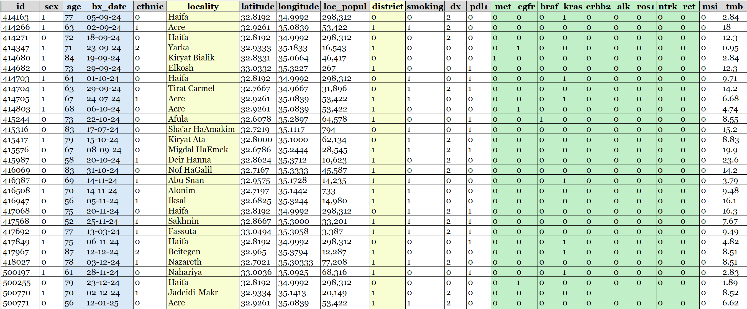

# Appendix B. Selected Python Code Scripts (For the Data Preprocessing)

## Installing Necessary Packages (Libraries)

import pandas as pd

import numpy as np

import missingno as msno

import matplotlib.pyplot as plt

## Loading the Dataset

# NB: Change the path below to your local path

PATH = r"C:/Users/Asus/OneDrive/Desktop/ENV_EPI_SEMINAR/data/CarmelMC_LungCancer.xlsx"

df = pd.read_excel(PATH) # requires 'openpyxl' for .xlsx

## Quick Checking of the Data Structure

print("\n# Structure (df.info):")

df.info()

print("\n# First rows (df.head):")

print(df.head())

## Checking Missing Values and Basic Consistency

print("\n# Missing values per column (count):")

print(df.isna().sum())

print("\n# Missing values per column (percent):")

print((df.isna().mean() * 100).round(1).astype(str) + "%")

print("\n# Visualizing missingness (matrix + bar):")

msno.matrix(df)

plt.show()

msno.bar(df)

plt.show()

# Unique ID check (R: length(unique(patients$id)) == nrow(patients))

if 'id' in df.columns:

unique_ids_ok = df['id'].nunique() == len(df)

print(f"\n# Unique ID count equals number of rows: {unique_ids_ok} "

f"({df['id'].nunique()} unique ids vs {len(df)} rows)")

else:

print("\n# Column 'id' not found — skip unique ID check.")

# Summaries for numeric variables (R: summary(patients$age), summary(patients$tmb))

for col in ['age', 'tmb']:

if col in df.columns:

print(f"\n# Summary for {col}:")

print(df[col].describe()) # count, mean, std, min, quartiles, max

else:

print(f"\n# Column '{col}' not found — skip summary.")

# Frequency tables with NA included (R: table(..., useNA='ifany'))

def freq_with_na(series):

return series.value_counts(dropna=False).sort_index()

for col in ['sex', 'smoking', 'dx']:

if col in df.columns:

print(f"\n# Frequency table for {col} (including NA):")

print(freq_with_na(df[col]))

else:

print(f"\n# Column '{col}' not found — skip table.")

# Appendix C. Declaration of authenticity

I hereby declare that I have written this seminar work myself. I affirm that this is my independent work, without full or partial copying from any source or full or partial purchase of the work.

This paper is submitted exclusively for the course "Environmental Epidemiology (אפידמיולוגיה סביבתית)" and has not been and will not be submitted in the future for any other course.

Signature:  (Nikolai Danilov)